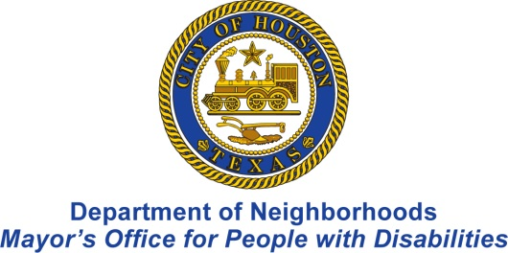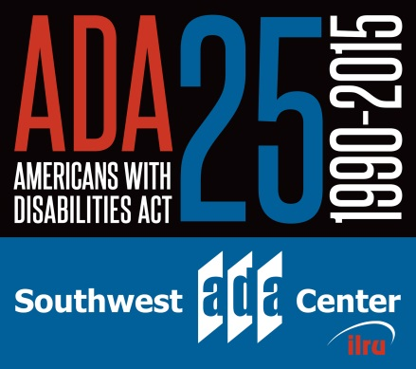

25th anniversary of the Americans with Disabilities Act (ADA)

You were selected for this notice, as a professional offering service to people with disabilities. The Mayor’s Office for People with Disabilities (MOPD) and the Southwest ADA Center, are offering a workshop to reacquaint or initiate your knowledge of the ADA, during this 25th Anniversary year.

Areas covered ADA General Overview and Emerging Issues
This full day session will help increase your knowledge and understanding of the general principles of the ADA and the ADA Amendments Act of 2008 (ADAAA). The ADA Amendments Act (the ADAAA) has changed the landscape of the Americans with Disabilities Act. This training covers who is covered by the ADAAA, and what the changes mean for employers, government entities, places of public accommodation, and individuals with disabilities. We will discuss the titles I, II and III under the ADA and how they apply to the areas of work you are doing with and around the community. We will also cover the Fair Housing act and discuss emerging issues and give guidance and resources as to how you can help.

When: April 14, 2015, 9:00 am to 4:30 pm

Where: Metropolitan Multi-Service Center, 1475 West Gray, Houston, 77019

Registration: required
Please register at the following link or call 832 394 0814
http://www.houstontx.gov/disabilities/rsvp.html
If accommodations are needed, please send an email to mopdmail@houstontx.gov or call (832) 394-0814 to explain your accommodation needs.

Registration and accommodation requests are due by close of business (5:00 pm central) on Friday, April 10, 2015.

