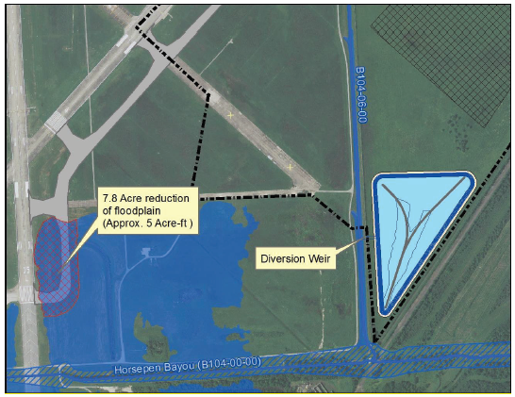
The Houston Airport System (HAS) is proposing to construct a parallel taxiway to provide access to Runway 4-22 and Runway end 35L at Ellington Airport (EFD) to address safety and efficiency of the EFD airfield. The proposed project would include construction of a taxiway (Taxiway Lima) with a width of 75 feet, length of 10,295 feet, and 30-foot shoulders. Additionally, there would be five runway connectors each approximately 500 feet in length, and two apron connectors about 150 feet in length.
A portion of the taxiway would encroach upon approximately 339,768 square feet (sf) or 7.8 acres of a regulated floodplain (Horsepen Bayou floodplain), resulting in reduction of approximately 5.0 acre-feet of flood storage. A map showing the project is available on this page. The environmental review, consultation, and other actions required by applicable federal environmental laws for this project are being, or have been, carried out according to FAA Order 1050.1F. Per Order 1050.1F and Executive Order 11988, Floodplain Management, HAS and the Federal Aviation Administration (FAA) has determined the proposed project is located within the 100-year floodplain. HAS and FAA are presently identifying and evaluating the potential impacts, if any, on the floodplain. Consultation with the Harris County Flood Control District was conducted to ensure the project would meet all applicable floodplain regulations. A stormwater detention basin and diversion weir near the site have already been constructed to provide compensatory storage for the encroachment on the floodplain. Therefore, impact on the floodplain is anticipated to be negligible. The encroachment would not impact existing infrastructure, would not have adverse impacts to the floodplain’s natural and beneficial values, would not have a high probability of loss of human life, safe airport operations would not be affected, and aircraft services would not be interrupted.
If requested, a Public Meeting to review the project and provide comments may be granted in accordance with FAA policy and floodplain review. If you would like to provide comments or request a meeting, please contact Kim Tourloukis, HAS Environmental Affairs by phone at (281) 233-1177 or e-mail at kim.tourloukis@houstontx.gov; or provide written comments or submit a meeting request by April 26, 2022, or 15 days from the start of the Notice Publication whichever is later. Written comments may be submitted by mail to Houston Airport System, Environmental Affairs, Attention: Kim Tourloukis, P.O. Box 60106, Houston, TX 77205-0106. Written comments from the public will become part of the project documentation.

