How to Prevent and Fix Problems with Web-Based Training Programs in LMS
This document addresses problems that may or may not be encountered when learners run web-based training (WBT) programs through the Learning Management System (LMS). These solutions pertains to current WBT titles, including CyberSecurity I & II, Executive Order 1-50 and other WBT titles both in the past and those to come in the future.

1. Run the Program Only in Internet Explorer
The only browser fully supported by COH information technology departments (i.e., HITS, PWE-IT, etc.) is the Microsoft Internet Explorer (IE) browser. Other browsers such as Google Chrome, Mozilla Firefox and others are NOT supported. Although you may be able to launch the LMS with these browsers, you will NOT be able to successfully run and complete a WBT course with them.
You can tell if you’re using a browser other than Internet Explorer based on the following visual clues:

Google Chrome
The Google Chrome browser has a tab that slopes more like the tabs on a paper manila folder, as shown below. Also, the “Back” arrow on Chrome is located below the tab.
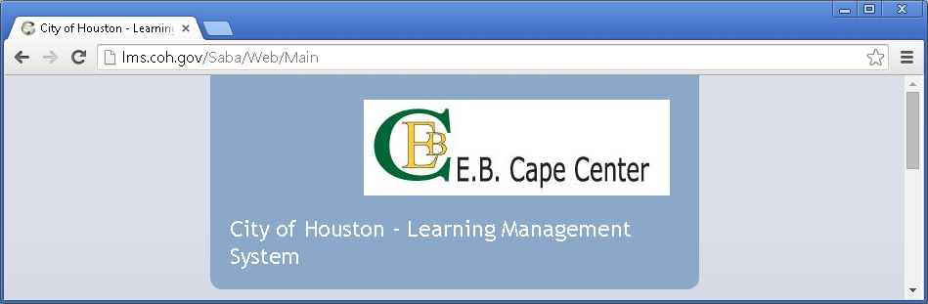
The tabs on a Chrome browser are sloped like on a manila folder.
The “Back” arrow on Chrome is below the tab.

Mozilla Firefox
The Mozilla Firefox browser also has tabs that slope like a paper folder. Its “Back” arrow is also located below the tab.
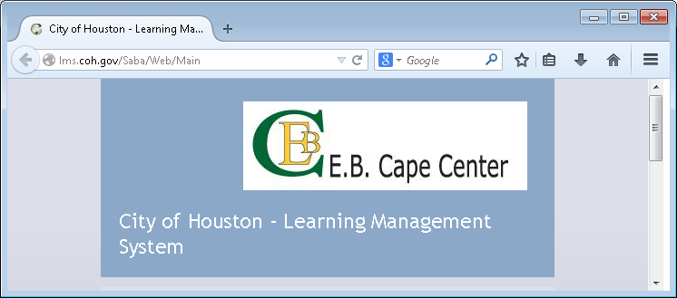
The tabs on Firefox browsers are also sloped.
The “Back” arrow on Firefox is below the tab and is in an unshaded circle.

Internet Explorer
The tabs on an Internet Explorer browser are square and its “Back” arrow is located above the tabs and is surrounded by a blue circle.
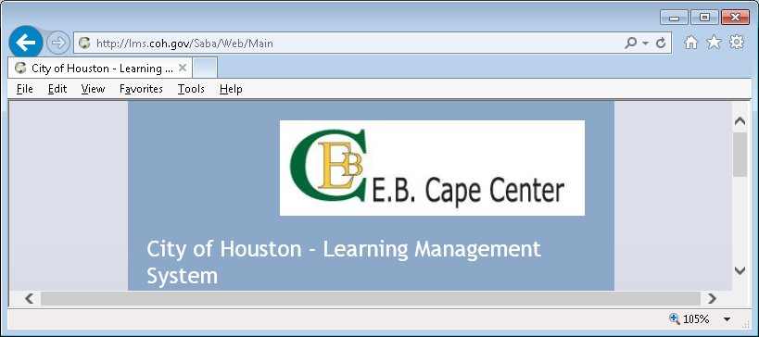
The “Back” arrow on Internet Explorer is in a blue circle and is above the tab.
The tabs on an Internet Explorer browser are square edged.
If you find you are using a browser other than Internet Explorer, close it and re-open the LMS in the proper browser.

2. Use Compatibility View Settings
Because there are several active and viable versions of Internet Explorer available and in use by various COH departments, you should always use the Compatibility View mode when working in the LMS, especially when doing WBT courses. The ensure you always work in the Compatibility View mode, you’ll need to add a couple of domains to your Compatibility View Settings in Internet Explorer. This will require you to select Compatibility View Settings from the Tools menu of your Internet Explorer browser. If the Tools menu is NOT visible, you will need to enable it.
Follow these instructions to enable the Tools menu and update your Compatibility View Settings.

Ensure the Menu Bar is Visible
The menu bar should be visible by default in Internet Explorer; however, if it is not, you can quickly enable it.
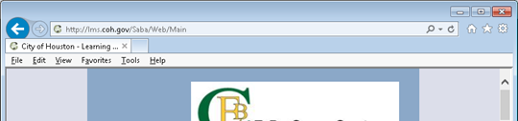
The menu bar menu on Internet Explorer is located below the tabs.

Enable the Menu Bar
To enable the menu bar, right-click in the blank space directly to the right of the New Tab control.
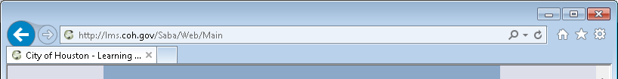
Right-click here
New Tab control

Enable the Menu Bar (Continued)
After right-clicking the empty space to the right of the New Tab control, select Menu bar from the pop-up menu.
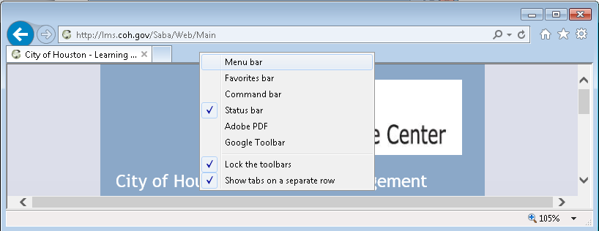
Select Menu bar from the pop-up menu
After selecting Menu bar from the pop-up menu, the Menu bar is visible.
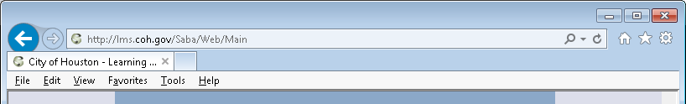

Select Compatibility View Settings from the Tools Menu
When the Menu bar is visible, click the Tools menu and select the Compatibility View Settings command from it.
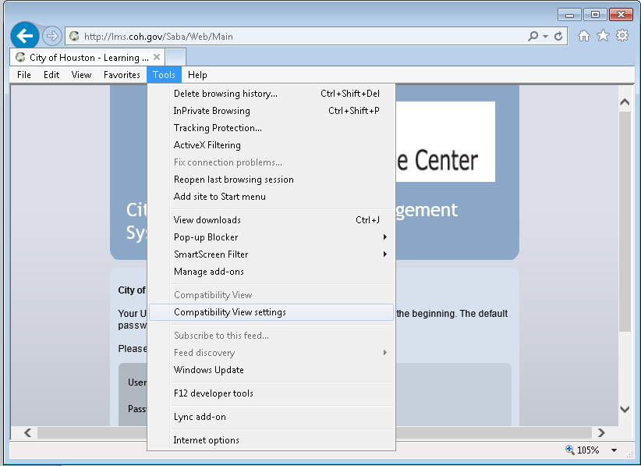
Select Compatibility View Settings from the Tools menu

Add the coh.gov Domain to the Compatibility View
If you are already in the LMS, the Add this website line should already have the coh.gov domain listed. If you do not see coh.gov on the top line, type “coh.gov” (all lower-case letters with no quotation marks). When coh.gov is listed on the top line, click the Add button.
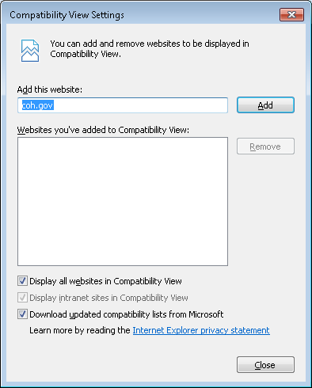
When coh.gov appears on the top line, click the Add button
Check to ensure that coh.gov is on the top line. If it’s not there, type it in.
After clicking the Add button, the coh.gov moves to the big box on the bottom, which shows the domains (i.e., websites) which will display with Compatibility View. That means ALL websites with the coh.gov domain will display in this view. Note: You may have other websites (e.g., kronos.com, cityhouston.net, etc.) listed in the lower box. For the purpose of this procedure, you may just ignore those entries.
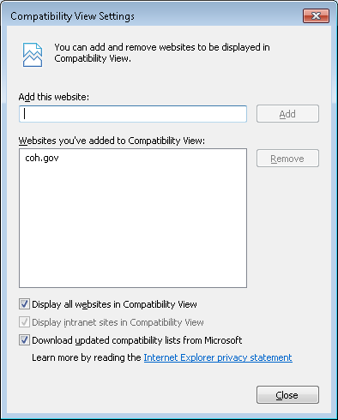
Notice that the coh.gov listing has moved down to the bottom box, indicating that all websites with that domain will display in Compatibility View mode

Add the houtx.lcl Domain to the Compatibility View
After the coh.gov domain has been added to the Compatibility View, repeat the process for the houtx.lcl domain. Type “houtx.lcl” (all lower-case letters with no quotation marks) into the top line labeled Add this website. When houtx.lcl is listed on the top line, click the Add button.
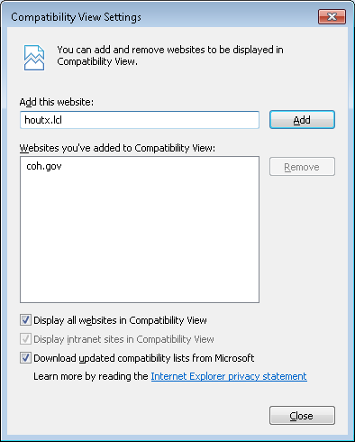
…then click the Add button.
Type houtx.lcl into the top line….
After clicking the Add button, the houtx.lcl moves to the big box on the bottom. After BOTH the coh.gov and houtx.lcl domains appear in the bottom box, click the Close button.
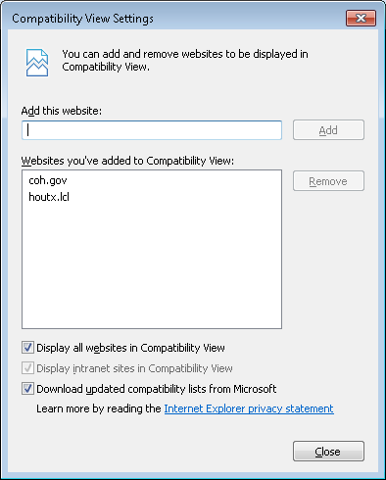
When BOTH coh.gov and houtx.lcl are listed in the bottom box, click the Close button
Notice that the houtx.lcl domain listing has also moved down to the bottom box.

Add the cityofhouston.gov Domain to the Compatibility View
NOTE: This setting is required only for those managers and supervisors who are running the HEAR application.
After the coh.gov and houtx.lcl domains have been added to the Compatibility View, repeat the process for the houtx.lcl domain. Type “cityofhosuton.gov” (all lower-case letters with no quotation marks) into the top line labeled Add this website. When cityofhouston.gov is listed on the top line, click the Add button.
Type cityofhouston.gov into the top line….
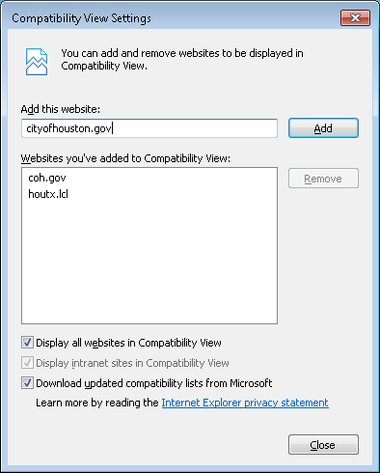
…then click the Add button.
After clicking the Add button, the cityofhouston.gov moves to the big box on the bottom. After ALL THREE of the domains (i.e., coh.gov, houtx.lcl and cityofhouston.gov) domains appear in the bottom box, click the Close button.
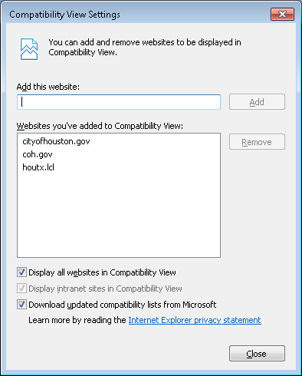
When ALL THREE domains (i.e. coh.gov, houtx.lcl and cityofhouston.gov are listed in the bottom box, click the Close button
Notice that the cityofhouston.gov domain listing has also moved down to the bottom box.

3. Disable the Built-in Internet Explorer Pop-up Blocker
Internet Explorer has a built-in pop-up blocker that automatically detects when programs try to open a new window from the current window. Because the Saba LMS content player requires that WBT content run in a separate pop-up window, the built-in pop-up blocker may prevent your being able to run the WBT content. You may or may not encounter problems in running WBT courses due to this or other pop-up blockers.
Because the LMS is a trusted website behind the COH firewall, you should ALWAYS trust content from the LMS and ALWAYS allow pop-up windows from the LMS to open.
Follow these instructions to instruct the built-in pop-up blocker to ALWAYS allow pop-ups from the LMS.

Launch the Content in the LMS
After you have logged into the LMS in an Internet Explorer browser AND added BOTH the coh.gov and houtx.lcl domains to the Compatibility View Settings, click the blue Launch link to the right of the WBT course title you want to work with.
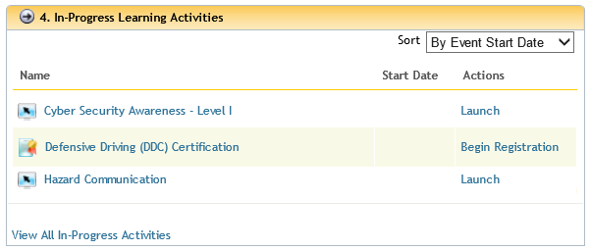
Click the blue Launch link to launch the WBT course.

Clear Built-in Pop-up Blocker
If your WBT content does NOT open immediately in a new pop-up window; or, if you clicked the title of the WBT instead of the Launch link, you will see the screen below. Click either of the gray Launch buttons to proceed.
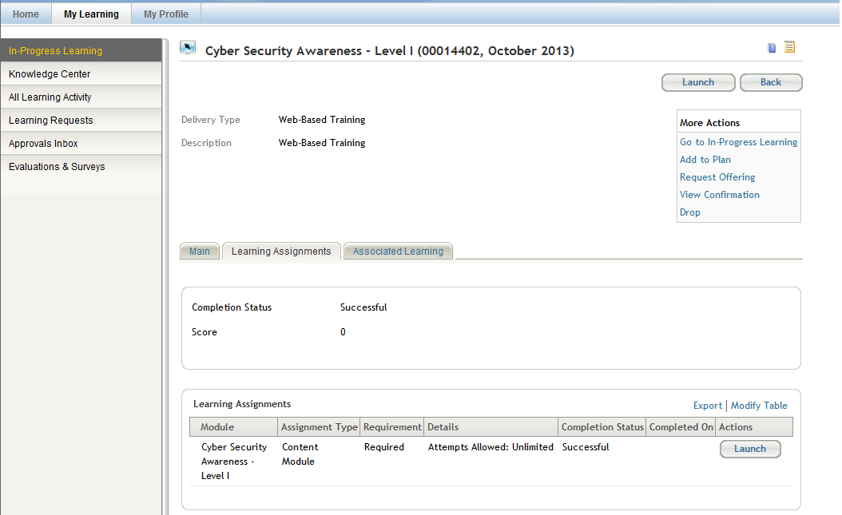
…or, you may click this gray Launch button instead.
Click this gray Launch button to launch the WBT course…

Clear Built-in Pop-up Blocker (continued)
If your WBT content does NOT open immediately in a new pop-up window, you should see the pop-up blocker box at the bottom of the screen, as shown below.
WARNING: You will have only about 15-20 seconds to perform the next step! If you do not clear the pop-up blocker within that time, you will be returned to the LMS Home screen. If you’re not fast enough to do this, return to the beginning of Step 3 and try again.
Click the small, black downward-pointing triangle (arrow) to proceed.
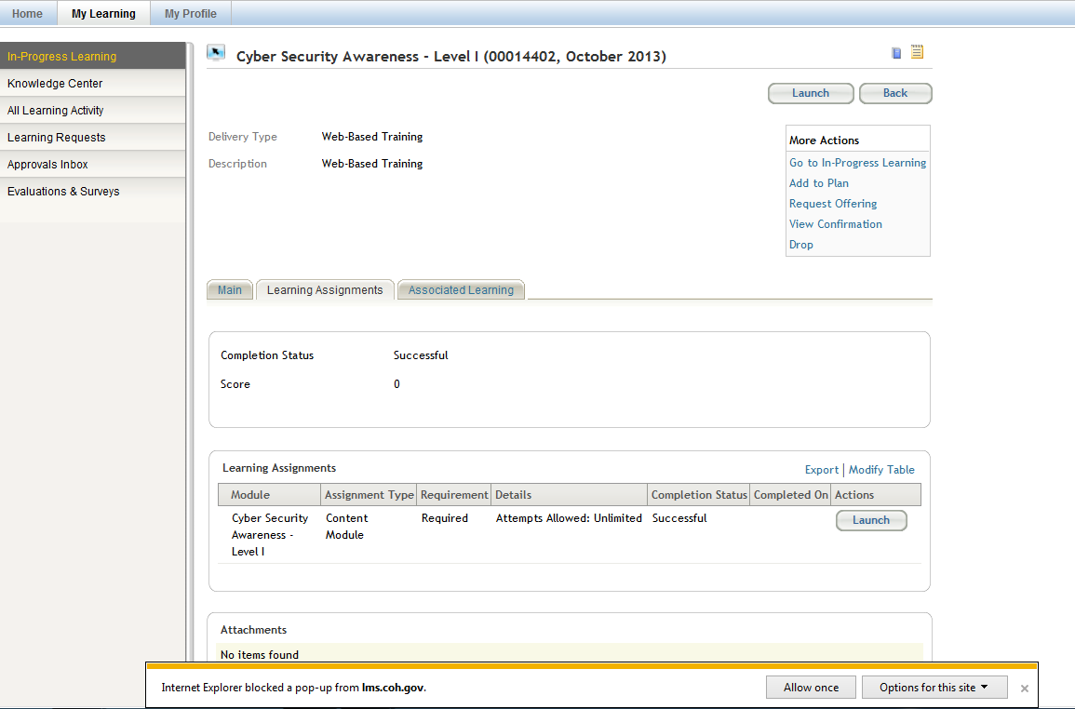
Click this black triangle to open a menu.
From the pop-up menu, select the option that reads “Always allow” – this ensures that you will ALWAYS accept pop-up windows from the LMS.
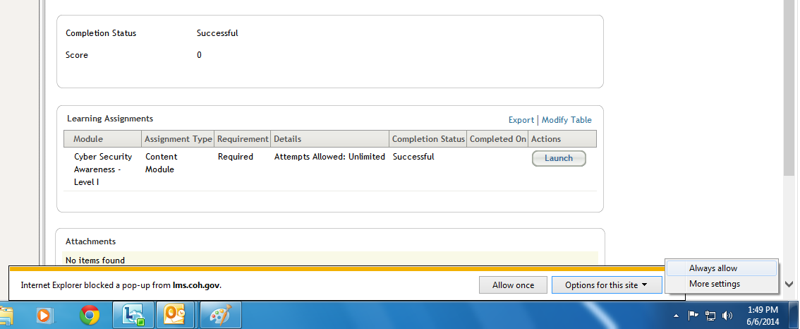
Click the Always allow option to allow any pop-up window from the LMS to open

4. Address Other Known Problems with WBT Courses
This document addresses the vast majority of problems that you may encounter with web-based training programs; however, there are a couple of other issues that may require help from your Information Technology (IT) support team. These issues include, but are not limited to, the following:
- No Flash Player (or outdated Flash Player) – This problem will require your IT support personnel to update your computer with the appropriate level of the Adobe Flash media player.
- No Sliverlight Player – This Microsoft media player add-in is similar to the Flash Player from Adobe and must be installed on your computer by your IT support personnel.

5. Address Other (Unknown) Problems with WBT Courses
There can be situations where you encounter an error or issue that is not covered in this document. In those cases, please contact your departmental LMS Administrator for assistance. He or she will be able to get priority assistance from the Learning Technologies Team, which will help ensure that your issue gets addressed in a most timely manner.

6. Complete WBT Courses
If you follow the steps in this document, you should be able to run and complete a wide variety of web-based training (WBT) programs through the LMS.
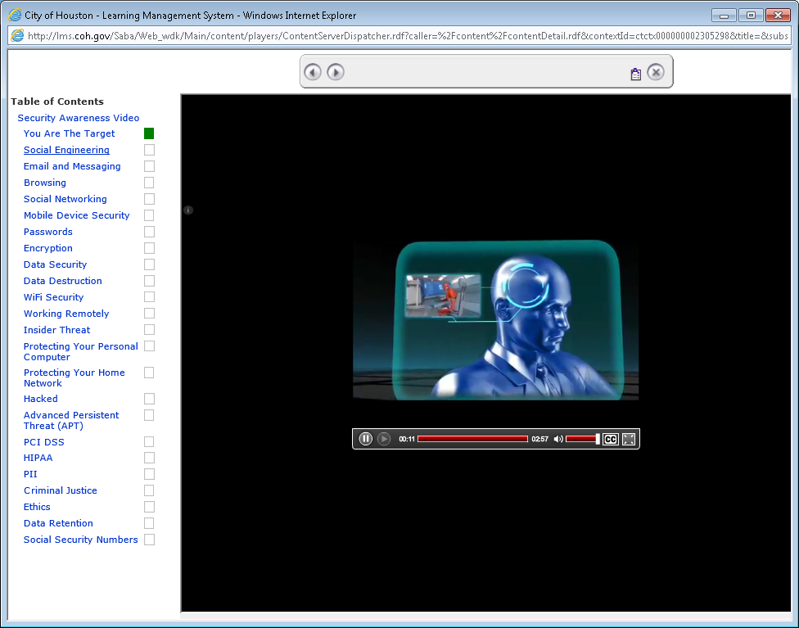
Screen Print from the CyberSecurity WBT
###END OF DOCUMENT###

