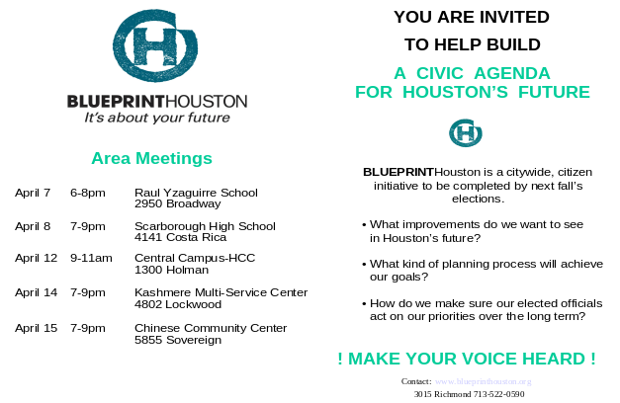

COMPENDIUM OF PLANS

Final Report

April 2003

 and Steven R. Spillette

TABLE OF CONTENTS

I. INTRODUCTION AND EXECUTIVE SUMMARY 1
Introduction 1
General Findings 2
Citywide / Regionwide Plans 2
Smaller-Area Plans 3
Relating Citywide/ Regionwide Plans to Smaller-Area Plans 4

II. CITYWIDE / REGIONWIDE PLANS 5
Plans Reviewed 5
Visions and Goals of Citywide / Regionwide Plans 6
Similarities / Commonalities 6
Differences / Conflicts 8
Gaps and Deficiencies Between and Within Plans 8
Community Participation 10
Relationship to Imagine Houston and R/UDAT 1990 10
Citywide Issues and Topics Not Covered by Plans 11
Basic Infrastructure: Water, Sanitary Sewer, Drainage 11
Education 11
Law Enforcement and Public Safety 11
Land Use 11
Pedestrians 12
Urban Form / Urban Design 12
Environmental Quality 12
Cultural Resources 12
Projects, Implementation, and Funding 13
Projects and Programs 13
Time Frames, Implementation, and Funding 13

III. SMALLER-AREA PLANS 16
Plans Reviewed 16
Geographic Coverage of Smaller-Area Plans 17
Classification by Geographic Focus 17
Area and Population 19
Visions and Goals of Smaller-Area Plans 19
Similarities / Commonalities 19
Differences / Conflicts 24
Gaps and Deficiencies Within and Between Plans 25
Community Participation 27
Relationship to Imagine Houston and R/UDAT 1990 27
Projects, Implementation, and Funding 28
Projects and Programs 28
Time Frames, Implementation, and Funding 28

IV. RELATING CITYWIDE / REGIONWIDE PLANS TO
SMALLER AREA PLANS 32
Similarities / Commonalities 32
Differences / Conflicts 33
Gaps and Deficiencies 33

APPENDICES

APPENDIX A: CITYWIDE AND REGIONWIDE PLAN SUMMARIES

2002 Consolidated Annual Plan A-1
City of Houston Bikeway Program A-3
City of Houston Library Strategic Master Plan A-4
City of Houston 2000 Major Thoroughfare and Freeway Plan A-5
City of Houston Parks and Recreation Master Plan A-6
Green Ribbon Plan A-8
Harris County Parks Master Plan A-9
Harris County Toll Road Plan A-11
H-GAC 2022 Metropolitan Transportation Plan (2002 Update) A-12
Houston 2000 Strategic Transportation Plan A-14
METRO Mobility 2025 A-16
R/UDAT 1990 A-17
TRIP 2000 A-18

APPENDIX B: SMALLER-AREA PLANS

Acres Homes Revitalization Strategy Plan B-1
Airline Corridor Revitalization Project Area B-4
Buffalo Bayou Master Plan B-6
Downtown Development Concepts B-10
Eastside Village Plan B-11
Fifth Ward (Western Sector) Revitalization Strategies Plan B-13
Fondren Southwest Revitalization Effort B-16
Greater Heights Area Community Plan B-19
Lyons Avenue Revitalization Plan B-22
Main Street Corridor Master Plan B-25
Main Street Corridor Strategic Plan B-27
Northside Community Plan B-28
Northside Village Economic Revitalization Plan B-30
Second Ward Action Plan and AIA Document B-32
Southern Houston Study B-34
South Houston Concerned Citizens’ Coalition Revitalization Strategies Plan B-36
Texas Medical Center Plan B-39
Third Ward Redevelopment Project B-41
Washington Avenue Coalition B-42
Westbury Revitalization Strategies B-43
Westheimer Corridor Mobility Study B-45
Zion’s Village Master Plan B-47

APPENDIX C: IMAGINE HOUSTON SUMMARY

Overall Vision C-1
Major Goals C-1
Community Safety C-1
Fostering Our Cultural Resources C-2
In Service to the Public C-2
Learning for Life C-4
Minding Our Natural Resources C-4
Taking Care of Ourselves C-5
Where We Live C-6
Where We Meet C-6
Where We Work C-7
Youth C-7

APPENDIX D: PLAN DATABASE MATRIX SUMMARIES

Geographic Scope of Plans D-1
Public Agency Sponsorship D-2
Plan Time Frames D-3
Issues Addressed by Each Plan D-4
Plan Purposes D-5
Plans with Vision Statements and Goals / Objectives D-6
Community Participation D-7
Plans with Implementation Strategies D-8
Plans with Funding Strategies D-9

LIST OF TABLES

Table III-1: Poverty Rates in the City of Houston and
Neighborhood Plan Areas 21
Table III-2: Change in Housing Units, 1990 to 2000 22
Table III-3: Change in Ethnic Populations in City of Houston and
Neighborhood Planning Areas, 1990 to 2000 23

LIST OF MAPS

Map III-1: Geographic Coverage of Neighborhood, Corridor, and Sector Plans 18
Map III-2: Planning Purpose: Neighborhood and Sector Plans 20
Map III-3: New Construction Permits and Neighborhood Plan Areas 26
Map III-4: Super Neighborhoods with Action Plans (SNAPs), 2002-2003 29
Map III-5: Tax Increment Reinvestment Zones (TIRZ) 31

Section I

INTRODUCTION AND EXECUTIVE SUMMARY

INTRODUCTION

This Compendium of Plans is a component of the Blueprint Houston effort, a major civic initiative funded by a grant from the Houston Endowment. Blueprint Houston seeks to initiate a public process to identify the vision, values, goals and priorities that Houstonians share and to define the best approach to planning for Houston's future, while effectively addressing the major issues, opportunities, and challenges facing the City over the next 35 years.

This report concerns the planning efforts that have been conducted over the last 13 years in Houston. It contains reviews and analysis of 35 plans addressing the urban condition and growth of the city. The oldest plan dates from 1990, while the most recent were produced in 2002. The plans are of varying geographic scope, purpose, topics, and formats, and are the work of a wide range of public agencies, civic groups, and community associations.

The purpose of this report is to determine the commonalities, differences, and gaps in the planning process and outcomes as expressed in these plan documents. During the research for the Compendium, the visions, goals, strategies, projects, and implementation components of each plan were summarized. These summaries are included as Appendices to this report. Information from the plans has also been entered into a database that has allowed further analysis, including geographic information systems (GIS) analysis.

The plans have been sorted into two main groups. Citywide or regionwide plans cover the entirety of the City of Houston – over 600 square miles by itself - and may cover wider areas such as Harris County or even the eight-county greater Houston region. Smaller-area plans, as the term implies, are concerned with subareas of the city such as neighborhoods, activity centers, or corridors. The findings of the Compendium review are similarly organized, with a section for each category, plus a section relating findings on the relationships between the two categories. The findings of the whole report are briefly summarized below.

GENERAL FINDINGS

- Contrary to popular perception, there actually has been a substantial amount of planning in Houston, from the regional level to the neighborhood level. Neighborhood plans alone cover 10.5 percent of the city’s area containing 14.8 percent of the city’s 2000 population.

- The format and content of plans as documents vary widely, since the plans have been developed at different times, by different entities, and for varied purposes. Some plans contain a full set of background demographic and economic data, a set of goals and strategies, specific planned projects, guidelines for implementation, and projected funding requirements and strategies. Other plans are primarily visioning exercises. Still other plans (especially transportation plans) simply reflect a series of planned projects by depicting them on a map.

- The plans reflect a planning process that does not incorporate effective coordination among different agencies, that focuses neighborhood planning efforts on distressed areas as opposed to high-growth areas, and does not directly address a variety of visionary issues of concern to many citizens (as identified in the Imagine Houston process).

CITYWIDE / REGIONWIDE PLANS

- There are two general categories of citywide / regionwide plans:

- Plans generated either by private / public efforts or multiple public agencies that advocate more sweeping visions and goals and coordination across agencies and planning issues, but do not present specific projects or implementation strategies.

- Plans by single agencies that focus almost exclusively on a single planning issue (parks, transit, bikeways, etc.). Many of these plans do not contain vision or goals statements at all, but they instead present projects that these agencies seek to implement.

It is difficult to find direct relationships or connections between the two categories of plans. It is possible that the vision or goal statements found in efforts such as Imagine Houston, a citywide visioning effort from the mid-1990s, may have played a role in the planning processes or resulting projects contained within the plans by implementing agencies, but it is not apparent from the plan documents. One exception is the city’s Parks and Recreation Master Plan, which actually mentions the Imagine Houston project.

- A key planning issue that is raised by transportation plans in category (1) and that plays a major role in the form and function of the region is transportation-land use coordination. Yet, apart from the Major Thoroughfare and Freeway Plan’s impacts on the city’s land development regulations (regarding setbacks and right-of-way), the transportation project and implementation plan documents in category (2) do not contain explicit reference to existing or future land uses.

- Many potential citywide or regional planning issues raised either in Imagine Houston or in smaller-area plans have no current or recent guiding plan of their own (capital improvement programs notwithstanding). These issues include basic infrastructure (water, sewer, drainage), education, pedestrian systems, urban form and design, environmental quality (apart from an air quality strategy), and cultural resources (the arts and historic preservation).

SMALLER-AREA PLANS

- Substantial parts of the city have been covered in smaller-area and neighborhood plans. The areas covered by neighborhood plans alone constitute about 65 square miles or 10.5 percent of the city’s area, and 289,000 residents or 14.8 percent of its population.

- Neighborhood plans cover areas that for the most part are stagnant or declining areas of the city, not areas that have recently experienced strong growth. Many if not most of the neighborhood plans focus on neighborhood stabilization and revitalization. In more general terms, the plans are reacting to fairly severe negative conditions existing today. Typical plan issues include housing, beautification, crime, economic development, and youth education and recreation. Census statistics for many neighborhood planning areas in Houston indicate higher than average vacant housing units, renter-occupied units, non-Anglo share of population, and youth share of population.

- In a related point, in most neighborhood plans concentrate on near-term stabilization and do not incorporate a larger “visionary” plan focus, perhaps due to immediate needs for provision of basic services.

- Community participation in most smaller-area plans appears to have been very strong.

- The neighborhood plans have an “inward” focus; that is, they do not discuss the neighborhood’s place within the city or region or relate to adjoining neighborhoods.

- In contrast, two of the corridor plans included in the review – the Buffalo Bayou Master Plan and Main Street Corridor Master Plan and Strategic Plan have a much more vision-oriented focus and a very conscious of their role in the region and their relationships to surrounding areas.

- The implementation process of neighborhood plans is unclear, since there is no mandatory validation of these plans by public agencies outside of the Planning and Development Department of the City of Houston.

RELATING CITYWIDE / REGIONWIDE PLANS TO SMALLER-AREA PLANS

- Many of the issues addressed by Imagine Houston show up primarily at the neighborhood and corridor planning level. In fact, the very practice of generating neighborhood plans supports the goals put forth in the Imagine Houston effort.

- However, within most of the plan documents, there seems to be little reciprocal acknowledgement or relationship of the citywide or regional plans by implementing agencies and neighborhood and corridor plans. One illustrative exception to this is the Northside Village Plan, which attempts to correspond with METRO’s 2025 plan as well as other housing and economic development programs.

Section II

CITYWIDE / REGIONWIDE PLANS

PLANS REVIEWED

Of the plans reviewed for this Compendium, fourteen had a geographic scope that covered the City of Houston or areas beyond the municipal boundaries. Of these, ten consisted of plans prepared by and for public agencies that are the providers of infrastructure, facilities, and services. The remaining four consisted of plans created by private sector groups, cross-agency teams, or civic groups. A listing of the plans in these two subgroups is as follows:

Public Agencies

2002 Consolidated Annual Plan
City of Houston - Housing and Community Development Department (HCDD)

Harris County Parks Master Plan - Phase 1
Harris County - Parks and Recreation

Library Goals for Excellence
City of Houston

Houston-Galveston Area Council 2022 Metropolitan Transportation Plan (MTP)
Houston-Galveston Area Council (H-GAC)

METRO 2025 (in process)
Metropolitan Transit Authority of Harris County (METRO)

Parks and Recreation Master Plan
City of Houston - Parks and Recreation Department

2000 Major Thoroughfare and Freeway Plan
City of Houston

Green Ribbon Plan
Texas Department of Transportation (TxDOT)

City of Houston Bikeway Plan
City of Houston

Harris County Toll Road Plan
Harris County - Toll Road Authority (HCTRA)

Private-Public Efforts

Trip 2000
Greater Houston Partnership

Houston R/UDAT 1990
City of Houston and American Institute of Architects

2000 Strategic Transportation Plan
Multiple public agencies

Imagine Houston
City of Houston and citizens groups

Summaries of these plans are attached in Appendix A. The Imagine Houston project is summarized in Appendix C.

An important note regarding citywide and regionwide plans involves documents and policies that were not considered as plans but instead as laws and policies used for implementation. These include Chapter 42 of the City of Houston’s Code of Ordinances (subdivision ordinance), which is purely an implementation mechanism. Also, the capital improvement programs of the various public agencies covering the city are not considered plans. These are lists of funded projects with a relatively short time horizon. They also are subject to change on an annual basis and do not have a stated framework of vision statements, goals, or objectives to determine their content.

VISIONS AND GOALS OF CITYWIDE / REGIONWIDE PLANS

Of the fourteen plans listed, seven contained statements of vision and/or goals (sometimes termed objectives). Some plans, such as the 2002 Consolidated Annual Plan and the 2000 Major Thoroughfare and Freeway Plan, contained extensive background or accompanying information, but no vision or goal statements. Several plans, including the METRO 2025, City of Houston Bikeway, and the Harris County Toll Road plans, contain primarily maps with little or no accompanying documentation. In contrast to these plans, Imagine Houston was primarily a visioning exercise with accompanying objectives and no specific plan projects or implementation described.

Similarities / Commonalities

Several similarities were found among the sets of plans.

- The most obvious similarity of the above plans is their geographic scope. Even though some of them are regional in scope, and others may focus attention within specific areas, they all cover the entirety of the City of Houston. A summary of their geographic scopes is shown in Appendix D-1.

- The Private-Public Efforts share the characteristic of a more inclusive, strategic, and in the case of Imagine Houston, visionary focus. R/UDAT 1990, prepared by a private sector group, actually called for a vision statement for the metropolitan area, though it did not present one itself. Imagine Houston was primarily a visioning and values exercise that resulted in general vision statements and goals. The purposes of the other three plans would be better classified as strategy rather than vision.

In addition, the strategic recommendations of these documents often involve multiple public agencies or planning issues. For example, the 2000 Strategic Transportation Plan, while focusing on transportation issues, also includes considerations of clean air, economic development, and land use. In addition, it calls for coordination across the various transportation agencies such as the Texas Department of Transportation (TxDOT), the City of Houston, and Harris County. A matrix of the issues covered in each plan is presented in Appendix D-4.

The public agency plans, for the most part, are narrower in focus, as would be expected since each agency typically deals with a single or narrow range of planning issues. Of the ten such plans, seven focus more on a set of goals and actions directly related to guiding the future growth of their respective systems rather than enumerating values or creating visions. The purposes of the various plans are summarized in Appendix D-5.

- The parks and recreation master plans (City of Houston and Harris County) and the H-GAC 2022 Metropolitan Transportation Plan (MTP) are agency plans that specifically call for cross-agency coordination and even coordination across planning issues. The parks and recreation plans mention the need to coordinate with the Harris County Flood Control District and with whatever agencies are responsible for bikeway plans. They also address, albeit to a limited extent, environmental preservation and protection as an issue in addition to human-oriented open space and facilities. Since H-GAC is the federally designated metropolitan planning organization, its mission is to coordinate federal funding among the various public entities in the region that implement transportation improvements. The MTP has an implied cross-agency coordination, although such coordination is not explicitly detailed in the plan. The MTP also touches on issues related to, but not explicitly part of, transportation, such as air quality, environmental preservation, and land use.

- Another commonality in eight of the plans, both the public agency plans and the private-public efforts, is the prevalence of transportation as a planning issue – eight of the fourteen plans address transportation. The 2022 MTP, the 2000 Strategic Transportation Plan, and Imagine Houston are documents that address all of the various components of the transportation system at the regional level. The other five plans address specific components – roads and streets, toll roads, transit, bikeways, etc.
- Finally, there are commonalities between three of the civic-initiated transportation plans, the Greater Houston Partnership’s Trip 2000 report, the Houston 2000 Strategic Transportation Plan, and H-GAC’s 2022 MTP. All advocate more coordination between land uses and transportation systems (in the words of Trip 2000, “Change the Urban Scheme”) as one way to address transportation needs in the region.

Differences / Conflicts

Given that most of the public agency plans focus on specific categories of programs and improvements that have minimal overlap with each other, there is little in the way of obvious conflicts between these plans in terms of visions and goals. However, there were differences between the plans regarding vision statements and goals (or lack thereof) and the background frameworks for the plans.

- Several plans included demographic and economic trends analysis as background to their plan. Some of these plans include both of the parks and recreation master plans, the city’s library plan, and H-GAC’s 2022 MTP. However, the data sources used for projected conditions of such variables as population and ethnicity, for example, do not all come from the same sources. The 2022 MTP and Trip 2000 use H-GAC’s projections, while the library and parks plans use those from the University of Houston’s Center for Public Policy.

- There was a wide range of planning horizons. The 2002 Consolidated Annual Plan’s horizon, as dictated by the requirements of the federal Department of Housing and Urban Development, is only one year. Several of the transportation plans, including the MTP, TRIP 2000, and METRO 2025, have horizons in excess of 20 years. A summary of time frames by plan is shown in Appendix D-3.

- As previously mentioned, some plans have no expression of vision or goals, at least within their plan document. This is particularly true of some of the transportation plans include the city’s Bikeway and Major Thoroughfare plans, METRO’s 2025 plan, and the Harris County Toll Road Authority plan. Their plans are essentially a list or map of planned projects. This is in contrast to the Harris County and City of Houston Parks and Recreation master plans, which provide a full set of goals or objectives that guide the recommendations and projects set forth in the plans.

Gaps and Deficiencies Within and Between Plans

Given that the plans discussed in this section are all citywide or regionwide, there are few if any geographic coverage gaps within the City of Houston. (It is possible that there could be coverage gaps outside the city limits.) Examples of potential gaps within plans include:

- The 2002 Consolidated Annual Plan, while guiding a citywide department, lists various geographic areas targeted for the projects and programs described in the plan and in accordance with federal grant requirements. These requirements limit the target areas to certain qualifying populations, so other areas of the city that may have needs related to the planning issues addressed by these federal programs (affordable housing, infrastructure, and economic development) are not covered in the plan. It also has the short time frame of one year, a federal funding limitation, so there is no description of long-term initiatives or projects.

- The Green Ribbon Plan covers only TxDOT roadways and highways. Most streets in Houston, including major thoroughfares, are not TxDOT-administered, so the plan does not apply to them.

An apparent deficiency of several plans, as noted earlier, is the lack of vision statements or goals and objectives contained within the plan documents (though such elements may have been a part of the creation process). Such plans include:

- 2002 Consolidated Annual Plan
- METRO 2025 (still in process)
- 2000 Major Thoroughfare and Freeway Plan
- City of Houston Bikeway Plan
- Harris County Toll Road Master Plan

The organizations that prepared these plans may have been responding to a vision or a set of goals and objectives, but they are not described in the plans themselves, so it is unclear what has guided the recommended projects and policies.

Gaps also exist between plans that would appear to share policy relationships or physical relationships in their projects. This is most apparent with the various transportation plans.

- A minor but typical example of a relationship between plans is the Bikeway Plan, which shows some bikeways on major thoroughfares. Yet there is no stated relationship between the Bikeway Plan and the Major Thoroughfare and Freeway Plan.

- The most significant gap is the lack of an identifiable coordinating vision or set of goals that unifies the various transportation plans. The H-GAC 2022 MTP, TRIP 2000 and the 2000 Strategic Transportation Plan put forth issues, goals, and strategies that relate to a variety various transportation modes and agencies covering the City of Houston. However, the plan documents of the implementing agencies, most of which are simply maps showing planned and potential projects, do not document a tie-in to the goals and objectives of the more overarching plans.

A key aspect of this disconnect is the goal, stated in the overarching plans, of strategically coordinating effort among transportation agencies to plan transportation infrastructure in a manner conducive to changing the urban development patterns in the city and region. Again, without vision and/or goal statements contained within the plans for the individual transportation plans, it is difficult to determine if this goal is being pursued.

Community Participation

Most of the citywide / regionwide plans included a structured public participation and input process in their formation. Public agencies prepared seven of the fourteen plans in-house (sometimes using consultants) and included citizen input through a combination of surveys of residents, public meetings, submitted comments, and workshops with selected civic groups. Imagine Houston, R/UDAT 1990, and TRIP 2000 are classified as “community-created” plans, because civic groups or citizen collaboration largely determined their form and content. The City of Houston Bikeway Plan and Harris County Toll Road Plan do not contain information on the extent of public participation. A summary of community participation levels for the various plans is presented in Appendix D-7.

Relationship to Imagine Houston and R/UDAT 1990

Imagine Houston likely represents the most systematic, comprehensive, and complete recording of vision concepts espoused by Houstonians to date. The topics covered by Imagine Houston, however, stretch beyond the “hard” elements of physical infrastructure and public facilities issues typically addressed by citywide plans. Many of Imagine Houston’s recommendations deal with “soft” infrastructure - methods and patterns of social, economic, educational, and political interaction.

Imagine Houston’s recommendations most relevant to existing citywide / regional plans are found in a section title “In service to the public.” This section stresses the need for a comprehensive planning process that coordinates the planning for various elements of urban development in Houston. This has yet to occur, at least in an explicit process. Preserving and highlighting natural environments is also a prominent issue, under “Minding our natural resources.” The city’s and county’s parks and recreation plans do address this topic as a plan element. The city’s Park and Recreation Master Plan, in fact, was one of the only plans to actually include a reference to Imagine Houston.

R/UDAT 1990 was different from Imagine Houston in the scope of its issues and its purpose, which was to study specific planning issues. Its key recommendations, however, were similar to Imagine Houston in that they emphasized coordinated and comprehensive planning of regional systems. It also called for special plans to address a Green Ribbon concept, Buffalo Bayou, and bikeways. There are now plans to address all three (the Buffalo Bayou plan falls under Section III, Smaller-Area plans).

CITYWIDE ISSUES AND TOPICS NOT COVERED BY PLANS

Certain issues that have major impacts on the City of Houston’s development, growth patterns, and quality of life are not currently covered by existing citywide or regionwide plans. There are various reasons why such plans do not exist. These include political resistance, lack of coordinated jurisdictions, or historical lack of interest. However, current discussions concerning Houston’s future have made these issues and topics more significant in terms of planning.

Basic Infrastructure: Water, Sanitary Sewer, Drainage

The City of Houston has citywide administrative responsibility for water and sanitary sewer services and infrastructure in support of urban growth. The Department of Public Works prepares internal plans for these systems. However, the city does not adopt these plans, though it does use them to establish its Capital Improvement Program. Drainage system plans are administered by the City of Houston and the Harris County Flood Control District and also rely on Capital Improvement Programs for implementation strategy. Again, these plans are not formally adopted.

Education

Education systems, from childhood through adult education, are repeatedly cited as key factors determining Houston’s quality of life and are often an issue addressed in the city’s various neighborhood plans. School quality and condition is often a significant factor in urban growth and the location choices of residents. However, the City of Houston encompasses all or part of nine K-12 public school districts plus other districts providing post-high school educational services. These districts and institutions exist independently of municipal government and are not legally bound by municipal planning processes.

Law Enforcement and Public Safety

Crime rates and police services are also significant determinants of the location of growth within the city. In recent years, crime concerns have also influenced urban design and aesthetic qualities of development. The role of public safety and security issues could be elements incorporated into other plans that influence the city’s growth and form. Regarding fire and EMS services, the Houston Fire Department’s Strategic Plan (not included in this report) does not address the need for or role of future facilities or other resources as the city continues to grow and change. These decisions are guided by other processes that are not part of formally adopted plans.

Land Use

Land use, serviced by water and sewerage systems but supported by the framework of the city’s transportation arteries, is the most visible element of Houston’s form and function as a city, has been a very controversial topic in the city’s history regarding citywide planning. While the purpose of this report is not to advocate land use planning in the city, it is important to recognize that because land use indicates the distribution and density of population and activity, it has strong impacts on other issues for which Houston does have traditional citywide or regionwide plans, for such issues as transportation, parks and recreation, and libraries. Furthermore, as previously mentioned, three regional transportation plans (H-GAC 2022 MTP, Trip 2000, and 2000 Strategic Transportation Plan) have called for further examination and even integration of land use and transportation facilities to improve mobility in the region.

Pedestrians

Walking is the most basic element of transportation and one that has gained increased attention in recent years for its potential role in aiding the region’s mobility. H-GAC’s 2022 MTP states that an agency initiative is to create a regional pedestrian plan.

Urban Form / Urban Design

The physical arrangement and appearance of human improvements on the landscape is probably the most visually important aspect of Houston. Not only can urban form directly affect quality of life in Houston through aesthetic impacts, it also plays a role in other issues such as transportation and crime prevention. Currently, the City of Houston has tried to influence urban design through implementation mechanisms such as subdivision and landscape ordinances; however, there is no unifying plan that describes the city’s goals for its own appearance and functionality.

Environmental Quality

Environmental preservation of natural areas is addressed to a limited extent in the parks master plans. Air quality is also a concern in H-GAC’s 2002 MTP and the Houston 2000 Strategic Transportation Plan. However, apart from an air quality plan required by federal law, there is no overall vision or plan for addressing Houston’s environmental quality that is guiding other aspects of environmental preservation and protection.

Cultural Resources

Cultural resources such as the arts and historic properties figure prominently in the Imagine Houston recommendations. However, while certain public agencies have addressed these issues with individual investments and policies and civic groups have promoted awareness, no coordinated plan or strategy has yet been developed to include cultural resources as essential elements of the city’s growth and change.

PROJECTS, IMPLEMENTATION, AND FUNDING

Another component of these plans is specific projects and programs, implementation mechanisms, and funding levels and strategies.

Projects and Programs

While a detailed discussion of the projects and programs contained within the various citywide or regionwide plans is not possible in this report, there are some general points that can be made about the citywide / regionwide plans.

- The plans produced by the private sector or as the result of a civic effort generally do not describe projects or programs at a detailed level; their recommendations focus more on the planning process and conceptual projects (for example, improved regional coordination, high-capacity transit, formation of a comprehensive plan).

- Some transportation plans show system improvements on maps (METRO 2025, Houston Bikeway Plan, Toll Road Plan, Major Thoroughfare and Freeway Plan) but do not list the improvements as specific projects or programs. The only transportation plan that lists improvements as discrete projects is H-GAC’s 2022 MTP, although the projects are not extensively discussed in the context of a plan.

- The two parks and recreation plans and the City’s library plan have the most detailed project and program recommendations.

- In agency plans where specific projects or programs are described, there are occasions where specific projects of one agency technically fall under the responsibility of another agency. The HCCD’s 2002 Annual Consolidated Plan is an example because it calls for park and library projects. While these specific individual projects were not investigated to ensure compatibility with the parks and library master plans, it should be acknowledged that the potential for conflicts exists in cases such as these. The potential for coordination obviously exists in these cases as well.

Time Frames, Implementation and Funding

The plans also vary in the extent to which they delineate ways in which to turn their recommendations into reality. While some plans merely list projects, other plans address implementation and funding to a significant extent. Summaries of plans that contain implementation and funding strategies are shown in Appendices D-8 and D-9 respectively.

- The time frames of these plans vary widely, as mentioned above (also Appendix D-3). Some plans are very short term, looking ahead 5 years or less, while others stretch over 20 years. Furthermore, six plans offered no time frames at all.

- Several plans with a substantial number of recommended projects, particularly the parks plans, prioritized projects for implementation. However, the transportation plans generally give no indication of project priorities. H-GAC’s 2022 MTP includes a date of air quality “conformity” for each project as well as designation of short-term versus long-term funding. However, project prioritization is left to a separate document, the Transportation Improvement Program (TIP), which functions as a timing, implementation, and funding guide for a three-year period as mandated by the federal government for clean air purposes; this would be considered to be a similar implementation mechanism to a municipal Capital Improvement Program (CIP).

- Five plans, including the parks plans, the City’s Library plan, TxDOT’s Green Ribbon Plan, and the City’s Major Thoroughfare and Freeway Plan include recommended facility standards or design guidelines to help determine various aspects of future improvements.

- Eight of the plans contained language either specifying or suggesting potential funding strategies for the recommended projects and programs. Only four of these, however, actually estimated future costs: the 2022 MTP, the Houston 2000 Strategic Transportation Plan, the City’s Library Goals for Excellence, and the HCDD’s Consolidated Annual Plan.

- Most funding strategies tend to be fairly non-specific, recommending general funding sources or conceptual tools versus naming a particular funding strategy for a particular project. The exception is HCDD’s Consolidated Annual Plan, which is created to show the annual funding from various sources of affordable housing and community development funds.

- It is important to note that the funding sources named in the various plans often coincide, if not by specific program then by agency or taxpayer base. This underscores the competition for public resources that is always present but perhaps not openly acknowledged in the plans. For example, the two parks and recreation master plans, the City’s Library Goals for Excellence, and the Greater Houston Partnership’s TRIP 2000 all suggest bond issues as a potential funding source. In addition, City of Houston departments all receive funding out of the City Operating Budget and Capital Improvement Program, so any funding strategies across different plans that suggest these two sources could potentially be competitive with each other and subject to the preferences and priorities of the City Council.

- Lastly, one of the most significant commonalities in terms of funding strategies is the call for private sector contributions. Harris County’s Parks and Recreation Plan and the City’s Library Goals for Excellence both mention private sector cooperation and donations as an important funding strategy. TxDOT’s Green Ribbon plan focuses on public / private partnerships as the primary method of funding potential improvements.

Section III

SMALLER-AREA PLANS

PLANS REVIEWED

Of the thirty-six plans reviewed for the Blueprint Houston Compendium, twenty-two plans were for specific areas within the City of Houston. Geographic coverage of these plans ranged from corridors, neighborhoods to large sectors within the city. A list of the reviewed plans, classified by their extent of geographic coverage is as follows:

Corridor Plans
Buffalo Bayou Master Plan
Lyons Avenue Revitalization Plan
Main Street Corridor Master Plan & Strategic Plan
Westheimer Corridor Mobility Study

Neighborhood Plans
Acres Homes Revitalization Strategies Plan
Airline Corridor Revitalization Project Area (ACRPA)*
Downtown Development Concepts
Eastside Village Plan
Fifth Ward (Western Sector) Revitalization Strategies Plan
Fondren Southwest Revitalization Effort
Greater Heights Area Community Plan
Northside Community Plan
Northside Village Economic Revitalization Plan
Second Ward Action Plan
Second Ward AIA Document
South Houston Concerned Citizens’ Coalition Revitalization Strategies Plan
Third Ward Redevelopment Project
Washington Avenue Coalition*
Westbury Revitalization Strategies Plan
Zion’s Village Master Plan

Other Special Area Plans
Southern Houston Study
Texas Medical Center Plan

* Also contain special emphasis on a corridor within planning area, but are of wider geographic focus in their analysis than typical corridor plans.

This report acknowledges that specialized plans also exist for some of the city’s Super Neighborhoods and all Tax Increment Reinvestment Zones (TIRZs); however, these plans were not individually reviewed. Also, other specific areas or facilities of the city may also be covered by special improvement projects or policies but were not considered “planned” areas on the level of those included here. Examples include the city’s airport facilities, Hermann Park, and the Cotswold Project streets in Downtown. Finally, masterplanned private developments such as Kingwood and Parkway Villages were also not included in the review.

GEOGRAPHIC COVERAGE OF SMALLER-AREA PLANS

A significant portion of the City of Houston has been covered by smaller-area plans, particularly the portions of the inner core of the city. Fourteen out of the twenty-two plans have been prepared for areas within IH-610 and include several of the oldest neighborhoods in Houston. Eight plans cover areas between Loop 610 and the Sam Houston Tollway. Map III-1 shows the geographic coverage of the smaller-area plans.

Classification by Geographic Focus

The smaller-area plans were classified by their geographic focus into three main groups:

- Corridor plans
- Neighborhood plans
- Other special-area plans

Neighborhood and neighborhood subarea plans dominate the list, comprising sixteen of the twenty-two smaller-area plans. These plans typically address an area of the city unified by history of development, a common problem, population characteristics, surrounding physical or geographic constraints, or simple popular conception and designation. In addition, some of the neighborhood plans address sub-areas within larger planned areas. For example, Eastside Village and Zion’s Village have their own neighborhood plans even though they are a part of the larger Third Ward; this allows a planning focus on issues more specific to these “subareas.”

The corridor plans are concerned with the corridor itself (a street or natural feature such as Buffalo Bayou), developments along the corridor and linkages to neighboring areas. For example, the Main Street Plan focuses on redevelopment strategies that integrate the corridor with significant developments or activity centers along it within the study area. The Westheimer Corridor Study included areas 1,000 feet to either side of the centerline of Westheimer Road. The Airline Corridor Revitalization Project and Washington Avenue Coalition also focused on specific corridors, though these plans also stretch into adjacent areas in their background data and analysis.

The two Other Special Area Plans do not fit in other geographic classifications. The South Houston Study deals with a large swath of the southern part of the city covering over 89,000 acres that is lacking in adequate infrastructure and services. The Texas Medical Center Plan deals with a campus area that has unique characteristics, special needs and a single economic focus, yet is also one of the city’s (and region’s) most significant activity centers and destinations.
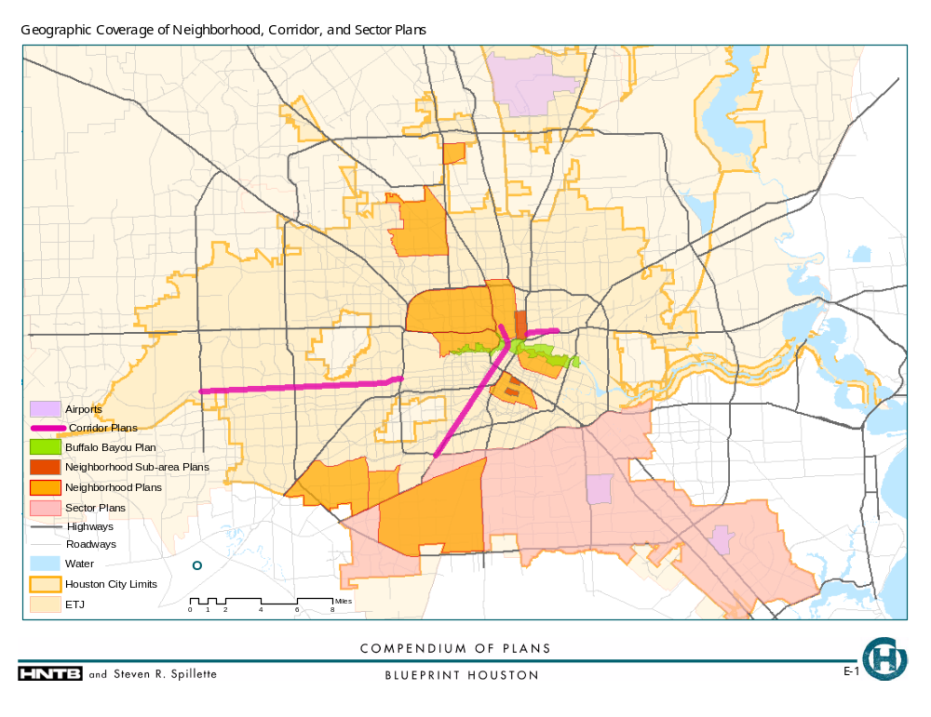
Map III-1

Area and Population

Areas covered by neighborhood plans range from 674 to 14,439 acres. The addition of the areas covered by neighborhood plans alone totals 10.5 percent of the city’s area. (This figure is probably slightly overestimated because of a small amount of overlap between neighborhood plans). The neighborhood plan areas are estimated to contain 14.8 percent of the city’s population, as estimated in the 2000 Census. (Again, this figure is probably slightly high.) The areas covered by the corridor plans were not calculated, as they were less strictly defined. The South Houston Study, as just mentioned, was by far the largest area covered in a plan.

VISIONS AND GOALS OF SMALLER-AREA PLANS

Similarities / Commonalities

The smaller-area plans shared many things in common – their purposes, issues, and public agency guidance. The neighborhood plans in particular showed many similarities and commonalities.

- A primary focus of fourteen of the smaller-area plans is neighborhood stabilization and revitalization (see Appendix D-4). Map III-2 shows the prevalence of revitalization as a plan purpose. Increasing home-ownership rates, reducing derelict properties and crime, investing in infrastructure and community facilities, improving education standards, improving the area’s appearance and attracting businesses and jobs are goals common to most revitalization plans. Most of these plans provide guidance on how to prevent further deterioration and as opposed to how to handle future growth.

The common characteristic of revitalization as a neighborhood plan purpose is in accordance with several demographic and economic trends typical of these plans. Plan boundaries of all the neighborhood plans are either coincident, within or an agglomeration of ‘Super Neighborhoods’ defined by the city. Using estimates derived from Super Neighborhood analysis of Census data, these demographic and economic trends indicate the concentration of smaller-area plans in economically stagnant or declining areas.

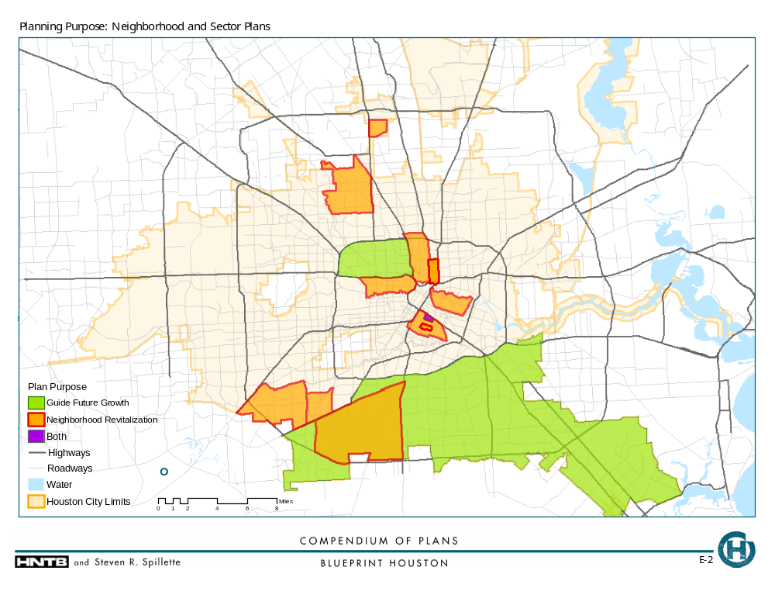
Map III-2
Poverty level is an initial indicator of the overall economic health in an area. The poverty rates as of the 2000 Census for the city and the neighborhood plan areas is as follows (the Downtown Development Concepts not included):

Table III-1
Poverty Rates in the City of Houston and Neighborhood Plan Areas

Plan Area | Poverty Rate  (2000 Census)
City of Houston | 18.9%
Acres Homes Revitalization Strategies Plan | 31.3%
Airline Corridor Revitalization Project Area | 24.5%
Fifth Ward (Western Sector) Revitalization Plan | 44.8%
Fondren Southwest Revitalization Effort | 17.9%
Greater Heights Area Community Plan | 17.6%
Northside Village Revitalization Plan | 29.1%
Second Ward Action Plan | 33.1%
South Houston CCC Revitalization Strategies Plan | 16.8%
Third Ward Redevelopment Project | 38.1%
Washington Avenue Coalition | 24.3%
Westbury Revitalization Strategies Plan | 16.8%

Source: U.S. Census and City of Houston.

The comparison shows that only four of the plan areas had poverty rates below the city average, and the others were substantially higher than the average.

In addition, many of the planned areas have a declining housing stock and lost housing units during the period from 1990 to 2000, even as the city overall gained a significant number of housing units (again not including the Downtown Development Concepts):

Table III-2
Change in Housing Units, 1990 to 2000

Plan Area | Change in  Housing Units
City of Houston | 55,560
Acres Homes Revitalization Strategies Plan | (1,895)
Airline Corridor Revitalization Project Area | (308)
Fifth Ward (Western Sector) Revitalization Plan | (645)
Fondren Southwest Revitalization Effort | (3,808)
Greater Heights Area Community Plan | (1,393)
Northside Village Revitalization Plan | (887)
Second Ward Action Plan | (83)
South Houston CCC Revitalization Strategies Plan | 422
Third Ward Redevelopment Project | (4,631)
Washington Avenue Coalition | 159
Westbury Revitalization Strategies Plan | 281

Source: U.S. Census and City of Houston.

Only three of these planned areas gained housing units during the 1990s. Corresponding to economic decline has been a decline in the traditional Anglo and African-American populations in these areas, with replacement by Hispanic residents, as shown in the following data:

Table III-3
Change in Ethnic Populations in City of Houston and
Neighborhood Planning Areas, 1990 to 2000

Plan Area | Anglo | African-American | Hispanic | Asian | Total*
City of Houston | 5,695 | 23,549 | 194,921 | 2,067 | 247,891
Acres Homes Revitalization Strategies Plan | (665) | 117 | 1,413 | 8 | 968
Airline Corridor Revitalization Project Area | (1,706) | (9) | 1,680 | (21) | 40
Fifth Ward (Western Sector) Revitalization Plan | 26 | (635) | 666 | (40) | 65
Fondren Southwest Revitalization Effort | (6,521) | 15,122 | 13,707 | (276) | 13,768
Greater Heights Area Community Plan | (1,339) | (693) | 1,469 | (12) | (226)
Northside Village Revitalization Plan | (1,173) | (1.073) | 2,424 | 82 | 198
Second Ward Action Plan | (65) | 431 | 102 | (54) | 448
South Houston CCC Revitalization Plan | (1,391) | (569) | 7,026 | 208 | 5,312
Third Ward Redevelopment Project | 860 | (2,915) | 1,244 | 42 | (333)
Washington Avenue Coalition | 476 | (300) | (37) | (1,226) | 261
Westbury Revitalization Strategies Plan | (2,187) | 426 | 4,121 | 629 | 3,241

* Total is for all ethnicities and not just the four shown in the table; columns will not add across.
Source: U.S. Census and City of Houston.

- Several issues are recurring elements in many of the smaller-area plans. A complete survey of the issues addressed in each plan is contained in the matrix in Appendix D-4. As the matrix shows, beautification and urban design was the most frequently addressed issue. Though several issues were common to many neighborhood plans, the specific goals and actions to address differed from plan to plan. Also, some issues in the above table may have been touched upon in some plans but were not addressed as a primary planning issue.

- Most of the neighborhood plans were prepared as a part of the “Neighborhood Planning Partnership Program” initiated by the Planning and Development Department at the City of Houston. The underlying common planning mechanism is reflected in the similar approach of these plans:

  - A “conditions assessment” in the form of a fairly extensive physical, demographic and economic profile of the area.
  - Identification of the most significant issues facing the community
  - Establishment of goals for addressing these issues
  - Formulation of action plans for achieving the community’s goals

The format of these plans is not completely rigid, however, and the plans vary particularly in the scope of information contained in their action plans.

Differences / Conflicts

Several of the smaller-area plans, while generally not in conflicting with each due to the separation of their geographical coverages, do show significant differences in their purpose and scope from the main group of neighborhood plans.

- While the neighborhood plans have very strong commonalities, some of them also have significant differences from the others. For example, the Northside Village Plan relates significantly to the Main Street Plan and the possibility of the METRO light rail extending through the neighborhood. Like other neighborhood plans, it addresses immediate issues facing the community, but it distinguishes itself by including a vision for the neighborhood’s future and presenting an in-depth analysis of some potential implementation strategies. For example, the plan suggests specific marketing strategies to attract new development and identifies community organizations that can help accomplish the plan’s objectives.

- The Washington Avenue Plan on the other hand is different because it has a single focus – physical enhancement of the Washington Avenue corridor through three specific improvement projects. All of the other neighborhood plans focus on a variety of issues facing the community.

- The most significant difference that sets the Main Street Plan, the Buffalo Bayou Plan, and the Downtown Development Concepts apart from other area and corridor plans is their scope and their foundation upon a new vision for their planning areas. The Main Street Plan extends beyond the immediate needs of the corridor to present a vision for creating the “Signature Boulevard” for Houston. This plan seeks to impact not only the Main Street Corridor and adjacent developments, but also the entire city by creating a special street unlike any other in Houston. Similarly, the Buffalo Bayou Plan seeks to create a unique “regional scale amenity that helps to create a vivid impression of the place”. The Main Street Master Plan and Strategic Plan also present development guidelines and implementation strategies in greater detail than most other plans.

- Southern Houston Study deals with a very large geographic region encompassing several neighborhoods. As the name suggests it is a study and assessment of infrastructure requirements in the area rather than a plan to help address the needs /deficiencies. The plan however makes recommendations like floodplain conservation, suitable land uses along specific corridors and development of revitalization strategies for distressed neighborhoods.

Gaps and Deficiencies Within and Between Plans

- Most of the neighborhood plans, the South Houston Study as well as the corridor plans with the few exceptions mentioned above are more “reactive” than “proactive” in nature. They were prepared to address decline and deterioration rather than to create a long-range vision to guide development and public improvements in the area. For the large part, these plans look at only immediate or short-range needs of the communities.

This point would be expected given the dominance of revitalization as a plan purpose and the fact that most of the plans date from within the last eight years (meaning decline is likely to be a current phenomenon). This leads to the ironic conclusion, however, that areas of the city where growth has been strongest tend to lack plans.

Map III-3 shows the varying densities of building permit activity, a barometer of the intensity of development and growth, overlaid by smaller-area plan areas. The map shows that the high-growth areas, signified by the darker shading, stretching from Midtown out to the west are not covered by neighborhood plans, with the exception of the Washington Avenue area.

- With the possible exception of the Northside Village Plan, all the neighborhood plans tend to concentrate on issues within the physical boundaries of the defined study area. There is no evident attempt to relate to planning efforts in proximate neighborhoods.

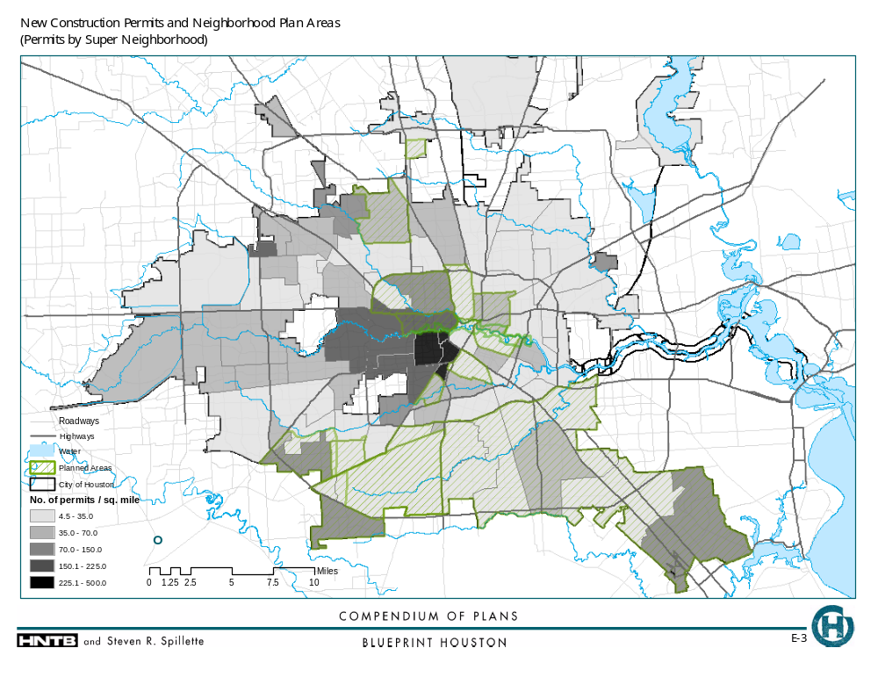
Notes:
Permits are for Years 1989-mid 2002
The map is based on 73% geo-coding match for the permits address database
Geo-coded shapefile was prepared by Knudson & Associates
Map III-3
- There seems to be no obvious link between the area plans and regional plans even when there is an overlap in issues under consideration. For example, most of the neighborhood plans talk about improved, additional recreational facilities for the youth, but there is no reference to the Parks and Recreation Master Plan provisions for the areas. The Texas Medical Center Plan mentions the need for improved transit connections and identifies significant access nodes outside the campus but, within the plan itself, there is no link to METRO’s plans or other transportation plans for the region.

Community Participation

The vast majority of smaller-area plans, both those created under the city’s neighborhood planning program and others, had a very strong community participation element, and several were even created primarily by civic or private groups. The matrix in Appendix D-7 shows that that the civic and private sector played at least a collaborative role in plan creation in nearly all plans. The vast majority, seventeen of the twenty-two plans, used an agency / community collaborative process to create the documents, the agency principally being the City of Houston Planning and Development Department. The Texas Medical Center Plan did not describe any participation from communities outside the campus boundaries, although the campus itself qualifies as a private sector or community-based entity. Only the Southern Houston Study, also prepared by the Planning and Development Department, did not explicitly indicate any public participation. The Southern Houston Study is as much of a background research on the area’s infrastructure and other service needs intended to guide future planning efforts as it is a plan itself.

The Washington Avenue Plan and the Northside Plan involved planning consultants in addition to the City and civic organizations. The Main Street Plan and the Buffalo Bayou Plan was similarly prepared by planning consultants with significant community participation.

Relationship to Imagine Houston / RUDAT 1990

Although there is no explicit link, several aspects of the Imagine Houston vision are reflected in the neighborhood and small area level planning that has been happening in Houston. The “Where we Live” Focus Group of Imagine Houston envisioned Houston as “a city of self-determined and self-governed neighborhoods where all stakeholders live, work, and play in community.” The formation of super neighborhoods, development of neighborhood plans for them through the Neighborhood Planning Partnership Program and Super Neighborhood Action Plans (SNAPs) are helping neighborhoods gain better control of their living environment. A large number of super neighborhoods are collaborating with the city to address the three most significant issues identified in Imagine Houston - neighborhood protection, stabilization and affordable housing.

The R/UDAT 1990 recommendations included “neighborhood stabilization” as an important planning priority for Houston. The report suggested that the absence of land use controls and expiring deed restrictions are creating an environment of instability in several Houston neighborhoods. This issue needs to be addressed at the neighborhood level in the form of neighborhood stabilization programs or plans for that would formulate regulatory mechanisms to meet the unique needs of different neighborhoods in Houston. As in the case of Imagine Houston, although the neighborhood plans have no direct link to the R/UDAT recommendation, they are working to address the underlying issue.

PROJECTS, IMPLEMENTATION, AND FUNDING

Projects and Programs

Projects / actions identified in the plans typically vary in complexity and specificity. They can be:

- Simple projects that can be completed by the community organizations without external help. Examples include formation of a chamber of commerce and citizen patrolling of neighborhoods.

- Projects that fall within the services provided by the city and can be potentially funded under the existing city budget. Examples include – vacant lot mowing, cleaning ditches, resurfacing streets and crime protection.

- Projects that may require substantial capital funding beyond that typically provided within the city department budgets. Examples include new school buildings, new community center, street reconstruction and provision of affordable housing.

Time Frames, Implementation, and Funding

The area plans reviewed, typically did not have very well defined time frames for implementation of projects. Most plans however made broad distinctions like “immediate”, “short range” and “long range” to help establish a sense of priority for the recommended projects. The Main Street Strategic Plan identified a time frame of twenty years for implementation of the Master Plan recommendations.

Although there is no direct link between the goals and actions type of neighborhood plans and the SNAPs, currently, SNAPs are the most appropriate mechanisms for implementing some of the projects listed on the neighborhood plans. Map III-4 shows the super neighborhoods that have adopted SNAPs.
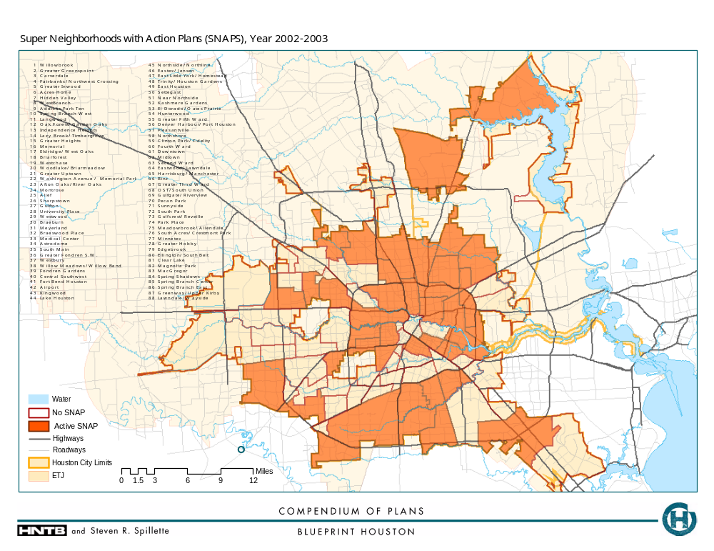
Map III-4

Under the SNAP process, super neighborhoods that have formed councils can work with the city’s Planning and Development Department to create an “Action Plan” for their neighborhood. An Action Plan is basically a prioritized list of services needed by the community and it is not required to be based on any visioning or goal formulating exercise by the community. Therefore, it is possible for a Super Neighborhood to have a SNAP without a neighborhood plan. On the other hand, the existence of a neighborhood plan doesn’t necessarily imply that the neighborhood has also formulated a SNAP to implement projects. In spite of this disconnect, SNAPs can serve as implementation mechanisms for neighborhood plans because they establish a formal communication conveying the community’s needs to the appropriate department /section. The city departments use the SNAPs as basis for prioritizing service provisions that are already budgeted. SNAPs can also help in transiting the capital-intensive projects that need CIP funding to the CIP list. Once a project is on a SNAP, the city knows that it is a priority for the neighborhood and it will work towards getting it onto the CIP list. However, there is no evidence of a definite link between the Capital Improvement Projects (CIP) list formulation process and the SNAPS or the projects identified by the neighborhood plans.

It is important to note that the neighborhood goals and action plans under the NPPP and SNAPs are two different programs – therefore transition from one to the other is not perfect. SNAPs are meant to address service needs of the community that are generally short range in nature. They are not vision or goal plans, neither do they necessarily relate to long-term goals for the community.

Tax Increment Reinvestment Zones (TIRZs) are another mechanism that can be used for implementing certain types of projects /actions identified by an area plan if it happens to be contained within a TIRZ. The Airline Corridor Revitalization Project Area for example, falls within the Greenspoint TIRZ. However, TIRZs have their own development plans that are not required to be based on any neighborhood or other area plans that might exist within the zone. This implies that there is no formal mechanism that would ensure the consideration /adoption of a neighborhood plan’s recommendations by an existing TIRZ. Therefore, as in the case of SNAPs, TIRZs are a possible but not a perfect implementation vehicle for an area plan. Map III-5 shows a map of existing TIRZs within the City of Houston.

The plans typically did not provide cost estimates for projects and identified only broad funding sources like the City, County or private investments. The plans did not get down to identifying specific grants / programs that could be targeted, or portions of city department’s budget that could be dedicated for their projects. The Main Street Plan provided an estimate of the total investment required for execution and the expected funding from local government, state and federal funds, and private and institutional funds. The Buffalo Bayou Plan also presents an estimate of expected funding in the form of private and public investments and presents a financial strategy to secure increased support and funding.
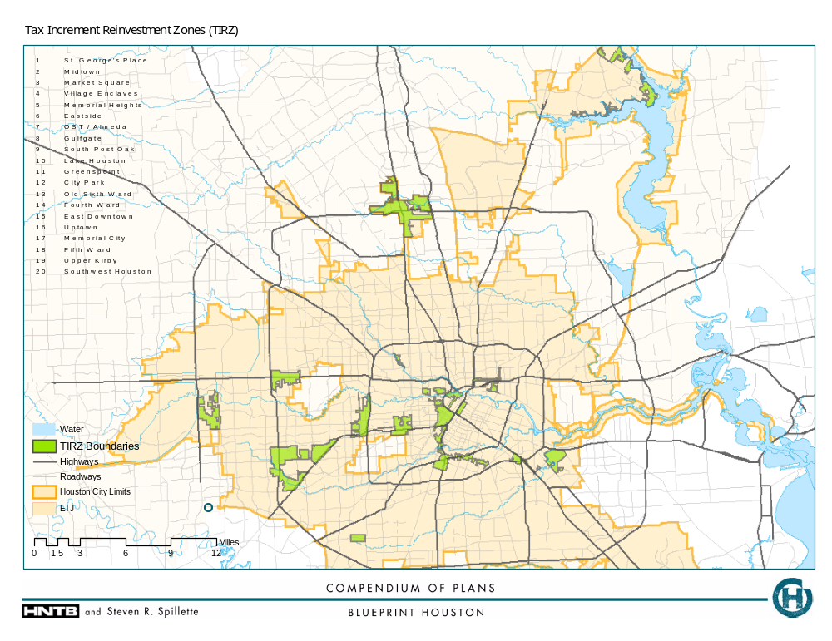
Map III-5

Section IV

RELATING CITYWIDE / REGIONWIDE PLANS TO SMALLER AREA PLANS

Effective planning in the City of Houston is determined, in part, by two major factors: (1) the extent to which each level of planning, from the region to the neighborhoods, reflects a shared vision and goals for the city, and (2) the coordination of projects, implementation, and funding recommended by the various plans. This section will examine the relationships between the citywide or regionwide plans and the smaller area plans on these two aspects of planning.

SIMILARITIES / COMMONALITIES

One of the most interesting similarities that can be found between the more “visionary” citywide plans, particularly Imagine Houston, and the neighborhood and corridor plans is that the small-area plans seem to incorporate many of the issues and goals of the citywide plans. For example, the issues of better housing, crime prevention, youth education and recreation, beautification / urban design, and neighborhood economic development are all typical elements of neighborhood plans. These same issues were addressed by Imagine Houston’s (and to some extent R/UDAT’s) vision statements and recommendations.

Other specific vision statements from Imagine Houston are reflected in certain small-area plans. These include:

- Imagine Houston strongly endorsed neighborhood-based planning, identity, and advocacy. The neighborhood plans represent this recommendation put into action.

- Management of Houston’s bayous for multiple uses was a focus of the vision for Houston in Imagine Houston. The Buffalo Bayou Master Plan represents a response to this call.

- The Northside Village Revitalization Plan highlights Imagine Houston’s desire both to develop measures that will reduce automobile use and increase historic preservation.

- The Main Street Corridor Strategic Plan, The Third Ward Redevelopment Project and its subarea plan Eastside Village are three other plans that support Imagine Houston’s vision of reduced automobile use.
- The Northside Village Revitalization Plan, which calls for a light rail line through the community, corresponds well with METRO’s 2025 plan as it currently stands.

DIFFERENCES / CONFLICTS

The most important differences between the citywide / regionwide plans and the smaller area plans is the level of “visioning” and the implied time horizon. Plans such as Imagine Houston and R/UDAT 90 primarily emphasized long-term visions and goals for Houston. Some of the smaller area plans take this view also; examples include the Buffalo Bayou Master Plan, the Main Street Master Plan, the Northside Village Revitalization Plan, and the Third Ward Redevelopment Project. However, many of the neighborhood plans focus primarily on short term, often relatively straightforward goals to quickly address current problems – a police storefront, improved maintenance of public rights-of-way, and cleaning up derelict or dangerous properties. This is likely due to the roles these neighborhood plans play in reacting to current negative conditions, as opposed to proactively pursuing a long-term vision for the area.

GAPS AND DEFICIENCIES

Perhaps the single most significant gap between the citywide / regionwide plans, in some cases, is that for the most part there is little thought to standardization of the planning process that incorporates multiple agency input and coordination. For example, the county’s Parks and Recreation Master Plan and the city’s Library Goals for Excellence can directly affect neighborhoods through public facilities. However, they do not reference any need to coordinate with neighborhood plans so that the agency can make sure it is acting in accordance with the vision or goals of a particular neighborhood. A contrasting example is the city Parks and Recreation Master Plan, which specifies in its goals to work with the city’s Planning and Development Department to make sure its parkland acquisition efforts are in accordance with the city’s long range planning goals, which would presumably take into account the small area plans that already exist. However, this plan appears to be the exception rather than the rule.

As pointed out in Section III, most of the smaller-area plans, particularly neighborhood plans, cover areas that have lagged in growth, while other portions of the city have experienced considerable new development and population gain. Many of the citywide plans concern public facilities and systems that will need to be expanded or modified to serve this growth. The result is that much of the growth in these facilities and systems will take place in places with no local-area plans to guide their implementation.

The various transportation plans, particularly those for implementing agencies, typically do not have goals or objectives let alone language calling for coordination with the goals and objectives of potentially affected neighborhoods. While smaller areas presumably have some input into formulation of these plans through whatever public participation process is used, there is no apparent direct link of existing smaller area plans into the citywide plan process and vice versa. The Northside Village Revitalization Plan, as mentioned earlier, is a useful case for illustrating the potential results of coordination between a regional and smaller area plan.

Also, as mentioned in Section II of this report, numerous issues that could be addressed through citywide or regionwide plans do not have any. These issues include several that are primary issues in the smaller area plans, such as basic infrastructure, crime prevention, education, and urban design. Each neighborhood or other smaller area therefore has no guiding citywide vision or goals for these elements (outside of Imagine Houston) and must address them in independent ways.

Furthermore, some issues raised by Imagine Houston get very little treatment in the smaller area plans. These issues include cultural resources and the arts, health care, and cultural diversity.

In summary, the lack of a comprehensive plan for the city is a major gap between the citywide / regionwide plans and the smaller area plans. With a comprehensive plan, the city could coordinate and relate the larger systems, such as transportation systems, with the needs and goals of individual neighborhoods or corridors.

APPENDIX A

CITYWIDE AND REGIONWIDE PLAN SUMMARIES

Note: In the following summaries, headings that are not followed by descriptive information indicate that these elements were not included in the plan document reviewed.

2002 CONSOLIDATED ANNUAL PLAN

Authoring organization, time frame, geographic area, and primary issues:

The City of Houston Housing and Community Development Department (HCDD) is responsible for preparing this document outlining its activities requiring federal funding for the current year. The plan essentially summarizes the various department programs and federal funding allocations that department will undertake during the year. Being a city department, HCDD can support projects anywhere within the city limits. However, the plan spells out specific target areas within the city for implementation of the various programs. These include:

- Community Development Areas
- Enhanced Enterprise Community
- Tax Increment Reinvestment Zones
- Neighborhoods to Standards
- State Enterprise Zones

Together, these areas cover a large part of the city, especially inside Loop 610 and various areas to the north, northeast, south, and southwest.

The department is primarily concerned with helping low and moderate income families. Its priorities are defined as follows:

- Housing and supportive services
- Public improvements and infrastructure
- Economic development

Plan creation and public involvement:

Plan vision statement:

Plan goals or objectives:

Strategies:

Key projects:

Implementation and funding:

Numerous specific programs that address each of these priorities are listed in the plan. There are four federal sources that are anticipated to fund these programs:

- Community Development Block Grants (CDBG)
- Home Investment Partnership Program (HOME)
- Housing Opportunities for Persons with AIDS Grant (HOPWA)
- Emergency Services Grant (ESG)

The total funding for which the city has applied is about $54.9 million.

CITYOF HOUSTON BIKEWAY PROGRAM (2002)

Authoring organization, time frame, geographic area, and primary issues:

A variety of public agencies within and outside the City of Houston government structure, coordinated by the Houston Bikeway Program, created the plan for the city’s bikeways.

Plan creation and public involvement:

The Pedestrian and Bicycle Advisory Committee helped formulate the plan.

Plan vision statement:

Plan goals or objectives:

Strategies:

Key projects:

The plan is essentially a map showing a variety of bikeways on local streets and thoroughfares and along waterways.

Implementation and funding:

The program receives 80 percent of its funding from the federal government and 20 percent from the City of Houston.

CITY OF HOUSTON LIBRARY STRATEGIC MASTER PLAN (1999)

Authoring organization, time frame, geographic area, and primary issues:

The Library Master Plan is intended to serve as the library system’s guide to physical and organizational growth through 2010. Coming from a department of the City of Houston, the plan addresses library needs throughout the area within the city limits.

Plan creation and public involvement:

The plan was created following research into the community’s assessment of library needs combined with analysis of demographic and other trends shaping the city.

Plan vision statement:

Plan goals or objectives:

While the vision and goals of the system are not explicitly stated, it is clear from the document that the department intends the library system to be world-class.

Strategies:

To gauge how the library is doing, the plan sets forth “Standards of Excellence” that provide concrete indices to measure service and facility provision.

Key projects:

The resulting recommendations are bold, calling for a restructuring of library bureaucracy and implementation of expanded information technology infrastructure. This would be coupled with a major facilities expansion including a new Central Library, a series of new Regional Libraries, 17 new or replaced neighborhood libraries, four renovated libraries, and an expanded Clayton Genealogical Library. Of special note were Student Learning Services facilities in every regional and neighborhood library to provide students on-line access and homework assistance.

Implementation and funding:

The total cost of these recommendations was estimated at $290.5 million. Since the plan recognized that direct city funding from the operating budget would not be nearly enough, it recommended a variety of funding strategies, including bond issues, partnerships, grants, fund raising, and fees.

CITY OF HOUSTON 2000 MAJOR THOROUGHFARE AND FREEWAY PLAN (2000)

Authoring organization, time frame, purpose, and primary issues:

The City of Houston prepared this map to indicate streets that are intended to follow certain standards of right of way, number of lanes, building setbacks, and other development actions. It is only concerned with higher-intensity streets and freeways. It covers the City of Houston and its extraterritorial jurisdiction.

Plan creation and public involvement:

A 1993 study was performed to define the classifications that would be used in future Major Thoroughfare plans.

Plan vision statement:

Plan goals or objectives:

Strategies:

Three classifications of streets are used:

- Principal thoroughfare
- Thoroughfare
- Collector

Key projects:

The plan consists solely of a map showing the designated streets.

Implementation and funding:

The plan was adopted by City Council in 2001. All development approvals must conform to the right of way and setback ordinances associated with the plan and related provisions in Chapter 42 of the city’s Code of Ordinances.
CITY OF HOUSTON PARKS AND RECREATION MASTER PLAN (2001)

Authoring organization, time frame, purpose, and primary issues:

The City of Houston’s Parks and Recreation Master Plan seeks to coordinate the development of the parks system with the changing size and nature of Houston’s population for at least the next ten years.

Plan creation and public involvement:

The plan extensively analyzes Houston’s demographic changes in terms of socioeconomic makeup including age and ethnicity. It also states that other plans were reviewed during the master planning process, including the 1993 Bikeway plan and the 1997-1999 Major Thoroughfare plan and other earlier plans relating to city parks and to Buffalo Bayou. The Imagine Houston project is also acknowledged as a statement of need for more parkland. The process also included public input through several means – surveys, community meetings, input from the Planning Department’s neighborhood planning efforts, and input from several civic organizations interested in parks and open space.

A needs assessment was also performed, using input from several sources, including national standards devised by other organizations.

Plan vision statement:

Plan goals or objectives:

A series of goals was developed for the city’s Parks and Recreation system:

- Provide parks and common open spaces adequate in size, distribution, and condition to serve all citizens.
- Provide recreational facilities and activities to fulfill the health needs and leisure interests of Houston citizens.
- Use the park system to preserve and protect environmentally significant areas for public enjoyment and education.
- Maintain, secure, and manage parks in a manner that encourages their appropriate use.
- Maximize public / private partnerships to assist in all aspects of parks and recreation planning and development.

Land acquisition target areas are also identified.

Strategies:

Key projects:

The plan goes on to specify recommended new and expanded facilities in fairly specific locations around the city and uses GIS to map these projects. The top priority in most areas of the city was renovation and rehabilitation of existing parks. More soccer fields and rehabilitation of pools were also very high on priority lists.

Implementation and funding:

Two key implementation tools are described by the plan:

- A set of standards and guidelines of each type of facility (for example, pocket parks, regional parks, special purpose parks, etc.) was developed to provide a guide for the location and site design of facilities.

- The various proposed expansions, renovations, and new facilities were prioritized for each sector of the city.

Interestingly, the plan explicitly states that implementation of linear parks should be coordinated with the city’s Bikeway Plan. There is also a long list of potential funding sources, but there is no specific funding plan presented in the document.

GREEN RIBBON PLAN

Authoring organization, time frame, geographic area, and primary issues:

TxDOT adopted this aesthetic and landscape master plan. The plan outlines design concepts for 2,700 centerline miles of TxDOT roadways.

Plan creation and public involvement:

Plan vision statement:

The vision is for TxDOT freeways in the Houston District to become "ribbons of green" to soften the concrete-dominated landscape.

Plan goals or objectives:

- Aesthetics
- Mobility
- Sustainability
- Sensibility
- Partnership
- Expression
- Innovation
- Artistic expression
- Involvement

Strategies:

Key projects:

Implementation and funding:

The Plan suggests public/private partnerships to supplement TxDOT funding to achieve the suggested aesthetic improvements.

HARRIS COUNTY PARKS MASTER PLAN (2001)

Authoring organization, time frame, geographic area, and primary issues:

Harris County created this master plan to address the future growth of the parks and recreation system that it administers, including facilities and programs within and outside incorporated cities such as the City of Houston. Previously, park development by Harris County had been done principally by the individual precincts with minimal coordination between precincts. This master plan was produced to create a “more global approach” to long range planning. It does not have a defined time horizon for the entirety of the plan but focuses on actions to take through 2006.

Plan creation and public involvement:

An extensive survey and other input from civic groups was used to develop the plan’s goals.

Plan vision statement:

Plan goals or objectives:

The plan defines several categories of park purposes, each of which has an associated set of goals:

Active recreation
- Acquire new or develop existing parkland for sports complexes
- Consolidate organized sports activities into larger complexes for more efficient management and maintenance
- Utilize smaller parks as practice facilities

Passive recreation
- Develop passive recreation within existing facilities, new land acquisitions, or interlocal agreements with municipalities or organizations

Open space and natural environments
- Continually identify, protect, and preserve quality natural open spaces

Strategies:

Some general strategies for accomplishing the plan’s objectives include:

- Adoption of standards and guidelines for park development to direct the location, size, facilities of existing and future parks.
- Improve all parks through compliance with accessibility, safety, and maintenance standards.
- Utilize common and shared facilities where possible and create a priority-driven maintenance guideline for fiscal responsibility.

Key projects:

Implementation and funding:

The plan recommends the pursuit of grants from the state and federal government to help fund improvements. The key organizational elements to guide implementation of the plan are a set of standards for various types of parks and a project prioritization schedule. Many recommended projects did not fall within the 5-year prioritization time frame but are listed as non-prioritized.

HARRIS COUNTY TOLL ROAD PLAN (2003)

Authoring organization, time frame, geographic area, and primary issues:

The Harris County Toll Road Authority (HCTRA) created this map of planned and potential future toll facility road and highway projects. In general, HCTRA administers toll road facilities within Harris County, although the plan indicates several potential facilities in surrounding counties.

Plan creation and public involvement:

Plan vision statement:

Plan goals or objectives:

Strategies:

Key projects:

The plan consists only of a map of planned and proposed projects. Major facilities shown include the Westpark Toll Road, the Grand Parkway, Fort Bend Toll Road, Katy Freeway toll lanes, and the Hardy Toll Road extension into Downtown Houston, plus other projects.

Implementation and funding:

The projects would generally be self-financed by future toll revenues.

H-GAC 2022 METROPOLITAN TRANSPORTATION PLAN (2002 UPDATE)

Authoring organization, time frame, geographic area, and primary issues:

The Houston-Galveston Area Council, the metropolitan planning organization for the region, is the creator of the 2022 Metropolitan Transportation Plan (MTP). The plan lays out the various transportation projects requiring state and federal funding for the next 20 years and covers the greater Houston region. It addresses a variety of modes and infrastructure – roads and highways, transit, and bicycle and pedestrian. In addition to accommodating growth in travel demand throughout the region, the plan must also address the issues of ongoing system maintenance, air quality and safety. The plan identifies several key transportation needs or problems to be addressed by the projects listed in the plan:

- Traffic congestion
- Maintenance and preservation
- Limited travel options
- Air quality
- Safety and security
- Transportation funding

Plan creation and public involvement:

The plan was prepared within the agency, with citizen surveys and public comment incorporated into the preparation process. While it is obvious that coordination with the various implementing agencies (municipalities, TxDOT, METRO, etc.) must have occurred, the plan is not explicit about this process.

Plan vision statement:

Plan goals or objectives:

The needs and problems identified by the plan lead to H-GAC’s goals:

- Increase the travel choices for people and freight movement
- Adequately maintain current roads and transit services
- Promote coordinated land use and transportation development
- Improve access to and connections within the transportation system
- Encourage the efficient movement of people and goods
- Establish and environmentally responsible system
- Create a cost effective and affordable transportation system
- Make the top priority the safe and secure movement of people and commodities

Strategies:

In response to the goals, the plan also identifies several strategies to address this problem:

- Reduce traffic congestion – through new roadway capacity, improved access control, eliminating gaps in the thoroughfare system, promoting transit and pedestrian access, effective facility management, and improved transportation / land use patterns.
- Increased maintenance and preservation funding
- Improve travel options – address modes and services for those who have reduce driving ability or lack automobile access, and make the best use of all transportation modes
- Air quality compliance – meet EPA goals
- Safety and security planning – systematically monitor auto crashes, improve system security
- Stable funding – seek a fairer share of state and federal funds

Key projects:

New agency initiatives named in the plan include:

- Transportation and land use – developing a better understanding of the relationship between transportation and land use through scenario building, examining things such as the role of transit-oriented development
- Intermodal congestion response team – provide immediate, low-cost solutions to congestion associated with freight transportation
- Bicycle and pedestrian plan
- Safety plan
- Expanded and improved transit service
- Unmet transportation needs
- Goods movement and its importance

The plan also lists all planned projects by various public agencies for which H-GAC must coordinate state or federal funding.

Implementation and funding:

Because H-GAC is essentially a coordinating and resource agency, not an implementing agency, implementation strategies are not spelled out.
HOUSTON 2000 STRATEGIC TRANSPORTATION PLAN (2000)

Authoring organization, time frame, purpose, and primary issues addressed:

A technical committee that included METRO, H-GAC, TxDOT, HCTRA, COH–P&D, COH–PWE, and GHP created this plan as a strategic framework to address issues associated with transportation and development in the Houston-Galveston Consolidated Metropolitan Statistical Area over the next 5 to 10 years.

Plan creation and public involvement:

Plan vision statement:

Plan goals or objectives:

- Maintain and preserve existing infrastructure
- Reduce Congestion (intermodal alternatives)
- Maximize Coordination (inter agency, between transportation, land development and other systems)
- Improve economic stability (increased linkages to the Port and Airports, good access to existing employment centers)
- Ensure International, inter/intraregional access
- Provide access for the transit dependant
- Address special and unique situations (environmentally sensitive areas, major activity centers, Clean Air Act conformity).

Strategies:

- Regional Cooperation – formation of a Regional Transportation Coalition
- Improved co-ordination of roadway network responsibilities – to include greater co-operation between the City and County resulting in greater County funds being spent in the City – increased county involvement in TIRZs.
- High Capacity Transit – key corridors developed for HCT, land-use strategies to reduce travel needs, expansion of METRO service area as the region grows.
- Smart Growth – Inter-relating transportation and land-use development policies.
- Intermodal connectivity improvements
- Bikeway and Pedestrian System
- Environmental Impact – clean air, floodplains
- Citizen Involvement – create a new organization, or allot additional funding to GHP /H-GAC to provide transportation improvement advocacy.

Key projects:

Implementation and funding:

The plan’s implementation strategy is to identify action items, a timeline, and a lead agency for each development strategy.

Funding Sources for Transportation Improvements:
- Local Funds (property and sales tax)
- State Funds
- Federal Funds
- Toll Revenues
- Fare Revenues
- Local Private Contributions

Project Costs: Expenditure Estimates for 2025 - $48.5 billion, estimated revenues - $48.3 billion, estimated shortage - $167 million

The plan identifies compliance with the Federal Clean Air Act by 2007 as the immediate priority for the region. Without this step, all other strategic improvements would have little benefit.

METRO MOBILITY 2025 (2001)

Authoring organization, time frame, geographic area, and primary issues:

The Metropolitan Transit Authority of Harris County (METRO) is in the process of creating a 22-year plan for its future major investments and service characteristics of public transit and high-occupancy vehicle (HOV) facilities. The plan covers the existing METRO service area and even beyond.

Plan creation and public involvement:

While METRO does have a public input process involving community meetings as the plan evolves, there is no plan document outlining the role of public involvement in plan formulation.

Plan vision statement:

Plan goals or objectives:

Strategies:

Advanced High Capacity Transit (potential light rail or bus rapid transit), HOV facilities, and expanded bus service are options under consideration.

Key projects:

The METRO 2025 plan is currently a very generalized, conceptual set of recommendations for future METRO investments and service represented on a map of the region. It identifies a set of regional corridors for study in regard to the implementation of some form of AHCT as well as other transportation facilities such as HOV lanes, transit centers, and park and ride lots. Because the plan is still evolving, further definition of projects and programs is expected.

Implementation and funding:

R/UDAT 1990

Authoring organization, time frame, geographic area, and primary issues:

This civic effort was coordinated by the City of Houston and the Houston chapter of the American Institute of Architects. It primarily focused on the role of planning in maintaining the financial health of public agencies within the Houston region.

Plan creation and public involvement:

Plan vision statement:

Plan goals or objectives:

Strategies:

The R/UDAT report recommends:

- Formulation of a Metropolitan Visions Statement
- Neighborhood Stabilization Program
- Co-ordination of Regional Systems (transportation, water/sewer, flood control, parks/open space, power distribution) as a framework
- Comprehensive Planning at the Sector level with land use regulation determined by the sector.

The plan also recommended improving bayous and parks as a means of enhancing livability, improving property values, and flood control.

The comprehensive planning strategy included some specific elements:

- Use of impact fees to mitigate negative effects of growth on public systems
- Development standards or performance zoning
- Rehabilitation or replacements of aging transportation system infrastructure
- Preservation of existing neighborhoods
- Special plans for Green Ribbon, Buffalo Bayou, and Bikeways.

Key projects:

The R/UDAT’s recommendations focused primarily on strategic processes as opposed to specific projects and programs.

Implementation and funding:
TRIP 2000 (2000)

Authoring organization, time frame, geographic area, and primary issues:

The Greater Houston Partnership, with some input from local and regional government organizations, created this document to publicize recommended strategies for improving mobility in the Houston region over the next 20 to 25 years.

Plan creation and public involvement:

Plan vision statement:

Plan goals or objectives:

A focus of the document is the need to seek a larger share and amount of funding from the state and federal government in order to implement improvements. Four main implementation objectives are named:

- Build more capacity
- Manage demand
- Increase system efficiency
- Change the urban scheme

Strategies:

A series of recommendations was made to accomplish these objectives. They include:

- Make sure the region receives its fair share of funding from TxDOT.
- Make sure the region receives a reasonable share of federal funding.
- Make sure local governments continue to fund transportation programs.
- Do more to increase total funding levels.
- Have better management of traffic incidents.
- Be “smarter” by making TransStar fully functional.
- Adopt a “mobility first” mentality by looking at the impacts of growth and investments on mobility.
- Strengthen regional mobility partnerships and leadership.

The key point to the document overall is that mobility reduction strategies and the funding to implement them must address a variety of aspects of transportation and urban growth, not just, for example, increasing roadway capacity.

Key projects:

Implementation and funding:

APPENDIX B

SMALLER-AREA PLAN SUMMARIES

Note: In the following summaries, headings that are not followed by descriptive information indicate that these elements were not included in the plan document reviewed.

ACRES HOMES REVITALIZATION STRATEGY PLAN (1999)

Authoring organization, time frame, geographic area, and primary issues:

The City of Houston partnered with the Acres Home Citizen Council Coalition to develop a plan for revitalization of the Acres Homes area, bounded by T.C. Jester, West Gulf Bank, I-45, and Tidwell. The time frame of the plan ranges from three months to three years.

The major issues addressed in the plan include:

- Public services
- Housing
- Land use
- Youth services
- Urban design / beautification
- Economic development

Plan creation and public involvement:

The community, represented by the Acres Home Citizen Council Coalition provided the impetus for the creation of this plan.

Plan vision statement:

Plan goals or objectives:

The goals to address the major issues are summarized as follows:

Public services
- Cleaned or improved ditches, upgraded culverts, and enforcement of city’s nuisance code
- Assurance that streets are maintained and rights of way mowed
- Sidewalks along all major thoroughfares and around schools
- Additional street lighting
- Permanent paramedic at local fire station and brush control around fire hydrants
- Mobilized political clout
- Location of abandoned hazardous utility sites
- Identification and reporting of parties responsible for dumping of hazardous materials

Housing
- Reverse negative perceptions about Acres Homes CDCs and community home builders
- Identify repair / rehabilitation programs for single family homeowners and multifamily developers
- Review Emergency Housing Repair Program criteria to find benefits for the community
- Promote stabilization of existing multifamily housing
- Identify four target areas for rehabilitation of 25 houses in each area in 24 months
- Construct 100 houses in the neighborhood over the next two to three years
- Form a partnership with Acres Homes CDC and a major multifamily housing developer to participate in the State Tax Credit Program

Land Use
- Create a proposed land use map concept to guide future development
- Stabilize existing residential areas

Youth Services
- Conduct a survey regarding youth service program needs
- Encourage representatives of the resident council and city housing authority to become involved in Acres Home planning process
- Recruit youth to serve on Youth Services subcommittee
- Develop database of existing youth organizations and programs
- Provide vocational, mentoring, recreational, sex education, parenting, and male initiatives programs
- Encourage local businesses to provide summer employment and entrepreneurial training to youth
- Address youth homelessness
- Address latchkey youth issues

Urban Design / Beautification
- Enhance environmental quality of Acres Home
- Improve aesthetic quality of Acres Home through various urban design / beautification projects
- Improve community parks

Economic Development
- Create 100 – 200 jobs in phases
- Strengthen the economic base of existing businesses
- Identify locations for a supermarket / strip shopping center

Strategies:

Key projects:
Implementation and funding:

Each goal is accompanied by an action plan that identifies resources, time frames, and funding sources. The plan recommends seeking funding from the city, Aldine ISD, and nonprofit groups.

AIRLINE CORRIDOR REVITALIZATION PROJECT AREA (ACRPA) (2000)

Authoring organization, time frame, geographic area, and primary issues:

The Greater Greenspoint Management District and the Airline Corridor Revitalization Committee prepared this plan in conjunction with the City of Houston Planning & Development Department. It focuses on revitalization of the neighborhood at the north end of Airline Drive, immediately south of the Greenspoint activity center, bounded by I-45, Aldine-Bender, West Road, and the city limits.

Primary issues addressed by the plan include:

- Beautification
- Crime and public safety
- Apartment relations (rehabilitation of multi-family housing)
- Parks, recreation and education
- Economic development
- Community relations

Plan creation and public involvement:

Plan vision statement:

Plan goals or objectives:

The plan included a set of goals to address each major issue:

Beautification
- Facilitate opportunities for public art to be incorporated into all beautification projects
- Ensure a litter-free environment in the project area
- Redesign the streetscape on the area’s principal streets and primary neighborhood entrances

Crime and Public Safety
- Promote civic pride and involvement in the community to eliminate graffiti and other criminal activity
- Improve existing infrastructure throughout the community
- Identify areas that need additional lighting and warning / traffic signals
- Discourage area businesses from selling alcohol and tobacco to minors and selling drug or gang paraphernalia.
- Enhance the awareness of itinerant business activity
- Support HPD neighborhood patrols and other efforts
- Discourage entrance / crossing into drainage area between Imperial Valley and Greenridge North subdivisions.
- Address the issue of homelessness.
- Enhance the awareness of the Airline Community HPD storefront.

Apartment Relations
- Establish an informal network of property management representative to improve management practices and foster community relations
- Increase involvement of multifamily and single family homeowners with the Apartment Relations Subcommittee and the informal network
- Establish a community standard for physical appearance of properties in the area
- Have the Stonebrook Apartments condemned
- Create, establish, and maintain youth programs for apartment residents

Parks, Recreation, and Education
- Build a SPARK park
- Identify and assist in marketing existing educational and recreational programs
- Identify and assist in marketing meeting room facilities
- Provide transportation to existing programs
- Build a park and community center

Economic Development
- Form an Airline Corridor Property and Merchants Association
- Restore the commercial vitality of the corridor and reverse the loss of local dollars by retaining existing core businesses and attracting new development
- Redevelop or renovate strategically located, underperforming retail and commercial properties
- Improve transportation access and mobility and identify strategies to make the area more accessible from within and outside the area

Community Relations
- Develop a community relations strategy to assist in the creation, implementation, and promotion of the Airline Corridor Revitalization Partnership

Strategies:

Key projects:

Implementation and funding:

Each goal has an associated action plan. Action items have been prioritized, assigned time frames for implementation, resources and responsible entities.

BUFFALO BAYOU MASTER PLAN (2002)

Authoring organization, time frame, geographic area, and primary issues:

The Buffalo Bayou Partnership (BBP), a civic group, prepared this plan with support from the Harris County Flood Control District (HCFCD) and the City of Houston. The plan covers a 10-mile corridor along the bayou from Shepherd Drive to the Port of Houston and includes parts of adjoining neighborhoods along the way. The plan works toward a 20-year vision by addressing the following issues:

- Environmental quality and eco-region
- Flooding
- Urban development and land use
- Landscape
- Waterfront access
- Recreational uses

Plan creation and public involvement:

A yearlong public participation process including three major consensus-building workshops was key to plan formulation. Since the plan was produced by a civic effort, it represents a community-created document.

Plan vision statement:

The plan’s vision centers around two themes: (1) multiple purposes of open land and urban land and (2) connectivity of natural habitats and environments for people. The resulting vision is described by a series of statements:

- The new Buffalo Bayou District is a place reclaimed – a place sustained once again by the flowing waters of the Bayou.
- A place that manages the impacts of flooding, protecting its people and assets from random acts of nature.
- A place that maintains the Bayou as a public resource, offering its banks and waters as a safe, clean, visible, and accessible amenity for all to enjoy.
- A place transformed in sympathy with nature and community, enriching its citizens’ quality of life and daily experience.
- A place that captures a region’s pride – central to Houston’s identity and a model for future green cities.
- A place busy with people, drawing residents and visitors to enjoy its destinations and neighborhoods, its commerce and culture along the rediscovered waterfront.

Plan goals or objectives:

The plan’s stakeholders came up with a list of goals and expected outcomes of achieving those goals:

Goals
- Revitalizing the waterway, Downtown, and all Bayou neighborhoods
- Providing a continuous and safe public amenity, with access for all
- Protecting life and property by managing flood impacts
- Increasing the effective synergy of government and businesses through a lasting public-private partnership

Outcomes
- Growth in the city’s economy with increased job opportunities
- An improved quality of life for Houston’s residents
- New businesses and residents attracted to the city
- A new image for Houston as a destination for cultural and ecological tourism

The plan lists the BBP’s objectives, categorized by the three main geographic areas of the corridor:

Buffalo Bayou West Sector (West End) - Shepherd Drive to Sabine Street
- Conduct site specific planning to upgrade the greenway ñ providing for improved landscaping and placement of amenities such as park benches, trash receptacles, public art and decorative lighting.
- Evaluate and assess the bayou’s natural setting in relationship to the growing trend of hosting special events and festivals along the bayou’s banks.
- Link bayou to adjacent neighborhoods that are experiencing growth.
- Improve access to bayou’s banks.

Buffalo Bayou Downtown Sector (Downtown) - Sabine Street to McKee Street
- Establish Buffalo Bayou as one of the unifying urban design element for downtown development projects.
- Identify areas for commercial development
- Secure consensus on whether the bayou should be controlled, as is the San Antonio River.
- Improve access to the downtown waterfront.
- Identify open space and recreational improvements, including bikeways, boating facilities, outdoor performance spaces, and other activities such as a farmer’s market.
- Identify specific features that can serve as focal points and signature elements for Buffalo Bayou in downtown.

Buffalo Bayou East Sector (East End) - McKee Street to Port of Houston Turning Basin
- The vision outlined in the 1993 Buffalo Bayou East Sector Redevelopment Plan is now becoming a reality. The Plan needs to build on this evolving revitalization along Buffalo Bayou's eastern sector.
- Identify increased opportunities for residential development along the bayou.
- Conduct site specific planning to improve underutilized and undeveloped parks along this bayou segment.
- Link bayou to adjacent neighborhoods.
- Develop ideas for the reuse of historic industrial properties.
- Create signature features and focal points highlighting the unique history of this bayou segment.

Strategies:

The key strategies employed by the plan include:

- Rehabilitate the Bayou as an ecologically functional system
- Increase floodwater conveyance capacity
- Promote low-impact development
- Improve visibility of the Bayou
- Ensure equity of access
- Increase residential opportunities Downtown
- Maintain affordability
- Create new jobs and revenue
- Promote joint public-private development

Key projects:

An extensive set of improvements and programs is proposed for the corridor. Highlights include:

- Creation of 850 acres of new parkland linking Memorial Park to the Turning Basin
- Fourteen new boat landings and excursion boat service
- Access improvements such as hike and bike trails and connections to adjacent neighborhoods
- Creation of “green fingers” to detain, filter and cleanse stormwater
- Creation and expansion of wildlife habitat areas
- Supplementary canals north of downtown to improve downtown floodwater flow and provide the central amenity of a new urban district
- Consolidation of bridge crossings that impede water flow

Implementation and funding:

To increase the likelihood that the plan’s vision is implemented, the plan proposes that creation of a new special district covering the corridor and including a new TIRZ in the eastern portion of the corridor. The TIRZ would have land use controls. Elsewhere in the district, special guidelines and modifications to the city’s current subdivision and platting ordinances would help ensure development that supports the plan’s vision. Also, the BBP would be restructured and expanded into three centers that could support plan implementation: a non-profit development arm, a conservancy, and a design center.

The funding strategies identified by the plan include:

Use of general obligation bonds backed by anticipated public revenues generated by new development (tax increment financing would be an example)

Special Congressional appropriations for improvements related to flood control, distributed through HCFCD

A variety of federal and state sources

A new municipal management or improvement district, or expanded responsibilities of existing districts

A regional assessment to benefit improvements along Buffalo Bayou and other area waterways and parks.

DOWNTOWN DEVELOPMENT CONCEPTS (1997)

Authoring organization, time frame, geographic area, and primary issues:

The Downtown Houston Management District, in association with its private counterpart Central Houston Inc., created a map overlaid on an aerial photograph that outlined a general vision for the different parts of Downtown Houston, within the loop of freeways I-10, I-45, and US 59.

Plan creation and public involvement:

Plan vision statement:

“Building on a $1.4 billion foundation of current projects, downtown will emerge by the year 2010 as a rich mosaic of urban district supported by enhanced transportation, public spaces and management services.”

Plan goals or objectives:

Strategies:

The map outlines a variety of strategic components, most notably specialized districts within Downtown, that will help to create the vision for the area:

- Management programs
- East Side Entertainment District
- Pedestrian-friendly streets
- METRO transit streets
- Skyline District / Houston Center
- Main Street
- Road and street improvements
- Transportation services
- Theater District
- Historic District
- Campuses
- Downtown greenbelt

Key projects:

Few specific projects are mentioned on the map. The METRO Transit Streets project, while not located specifically, is described. The need for park projects along Buffalo Bayou and extending south toward the convention center is also described in more detail.

Implementation and funding:

EASTSIDE VILLAGE PLAN (1997)

Authoring organization, time frame, geographic area, and primary issues:

Eastside Village is a subarea within the Third Ward, bounded by Elgin, Scott, Alabama, and Ennis. The City of Houston Planning and Development Department worked with the Southeast Houston Community Development Corporation (SEHCDC) to develop a plan for the neighborhood’s revitalization. Three main issues are discussed in the plan:

- Affordable housing
- Urban design
- Economic development

Plan creation and public involvement:

The plan was a collaborative effort between the city and the SEHCDC.

Plan vision statement:

Plan goals or objectives:

Strategies:

Physical planning and urban design are the two aspects of planning that the document endorses to address the plan’s major issues. It endorses pedestrian-friendly traditional neighborhood design.

Key projects:

A master plan identifies several locations for improvements and development: a “Village Center” area at Holman and Tierwester with a small public square; the Holman Street Baptist Church area; special corridors on Scott, Elgin, Holman, and East Alabama; the Village interior; a linear hike and bike trail along the Columbia Tap rail line; a commercial node at Ennis and Holman; and long-term redevelopment areas along Ennis that currently lack sufficient infrastructure.

The plan also discusses a development site across Holman from the Baptist Church. The SEHCDC would acquire and develop property into 12 residential units, making them available to lower income buyers. Other projects would be concurrent with the new housing included expansion of the church, Scott Street Enhanced Enterprise Community Corridor, Greater Third Ward Gateway Project at I-45 and Scott, and the Missy’s Landing apartments at Reeves and Scott streets. Elevations and floor plans for the SEHCDC housing units were also included.

Implementation and funding:

The SEHCDC, a nonprofit, would play a significant role in implementing some of the recommended projects and raising the needed funding. The Scott Street Enhanced Enterprise Community Corridor is another tool to encourage revitalization.
FIFTH WARD (WESTERN SECTOR) REVITALIZATION STRATEGIES PLAN (2000)

Authoring organization, time frame, geographic area, and primary issues:

This plan from the City of Houston Planning and Development Department focuses on the western portion of the Fifth Ward, bounded by US 59, I-10 East, Elysian, and Collingsworth. It has been losing population and housing units since at least 1980 and household incomes are typically very low.

The main issues addressed in the plan include:

- Housing
- Education
- Health and social services
- Environmental impact and urban design
- Public services
- Economic development

The plan focuses on changes that could be made within a three-year period.

Plan creation and public involvement:

After a revitalization plan for the Lyons Avenue corridor was created in 1995, a group of ministers from the western sector of the Fifth Ward asked the City of Houston Planning Department to help create a similar plan for their portion of the neighborhood. The result is a collaborative effort between the community and the city.

Plan vision statement:

Plan goals or objectives:

The plan associates goals with each of the six main planning issues.

Housing
- Develop a diversity of housing types
- Rehabilitate existing housing
- Attract new residents to the area

Education
- Enhance youth programs with the Fifth Ward and support existing elementary schools
- Promote language and literacy programs
- Promote self-sufficiency
- Form partnerships with business, education, and community entities

Health and Social Services
- Establish a permanent medical / dental clinic within the community
- Expand and utilize services in and around the community
- Provide drug education, anti-gang awareness, and a legal facility
- Provide Medicare/Medicaid and their social services to the elderly

Environmental Impact and Urban Design
- Improve physical appearance of Fifth Ward and reduce blight
- Make the neighborhood safer through environmental improvements
- Eliminate vacant, dangerous, and/or unlivable buildings

Public Services
- Eradicate gangs, drug/alcohol abuse, prostitution and graffiti
- Increase police visibility
- Stop alcohol abuse by minors
- Rid the community of hazardous waste, mosquito infestation, and pollution through workshops conducted by BFI, TNRCC, and Keep Houston Beautiful
- Improve and refurbish existing park facilities
- Coordinate with Public Works to improve community infrastructure

Economic Development
- Identify existing businesses
- Identify commercial structures that could be restores and appropriate commercial uses
- Create nodes of investment at Lyons/Jensen, Lorraine/Quitman, Quitman/Collingsworth, Quitman/Jensen
- Develop strategies to ensure that local businesses employ local residents and that local residents are familiar with and have access to job training and placement programs
- Identify and target entrepreneurial opportunities and develop a partnership with UH Business Entrepreneurship Program to assist this process
- Provide low-cost day care opportunities to local residents and develop opportunities for co-locating day care and job training programs.

Strategies:

Key projects:

Each goal has a series of recommended actions associated with it. Many if not most of the actions represent “soft” projects – not physical projects but programs to support social, governmental and communication efforts.

Implementation and funding:

The plan identifies actions to support the above goals and lists potential funding sources and other resources for each. These funding sources and resources range from local, state, and federal assistance to community nonprofits to civic groups and private donations.

FONDREN SOUTHWEST REVITALIZATION EFFORT (2000)

Authoring organization, time frame, geographic area, and primary issues:

Two community groups, Southwest Houston 2000, Inc. and the New Braeswood Revitalization Association, worked with the City of Houston Planning and Development Department to create a plan document for the 4.5 square-mile Fondren Southwest area, covering most of Super Neighborhood 36 plus some adjacent areas. The plan’s subcommittee names identify the main issues addressed:

- Apartment relations
- Beautification
- Community relations and image
- Crime
- Economic and business development
- Education, recreation, and youth
- Transportation

Plan creation and public involvement:

The plan represents a collaborative effort between the two civic associations and the city.

Plan vision statement:

Plan goals or objectives:

For each issue, the plan assigned the following goals:

Apartment Relations
- Open lines of communication between the area’s apartment/townhouse residents, homeowners, and rental housing managers and owners.
- Build trust and develop regular communication among multifamily complexes
- Identify problems and get connected with the proper resources to address those problems

Beautification
- Enhance all major thoroughfares, corridors and neighborhoods through beautification and aesthetic improvement projects
- Dissuade individuals from littering and persuade agencies, organizations, and property owners to remove litter and rubbish along all property, public rights of way, parks and private easements

Community Relations and Image
- Establish the Community Relations and Image Subcommittee as the clearinghouse, coordinator for media contact, internal and external provider of information to the community on the Revitalization Effort project and other broad based community organizations
- Facilitate effective communication throughout the community

Crime
- Eradicate gang activity
- Promote HPD’s and Precinct 5 Constables’ visibility and civic participation in anti-crime efforts
- Collaborate with property owners to reduce or eliminate criminal activities on their property
- Promote civic participation in the issuance and renewal of beer / liquor licenses
- Control pay phone abuse
- Identify trouble spots
- Prevent personal mail box abuse

Economic and Business Development
- Establish a merchants’ association
- Encourage residents to shop in their neighborhood, improve the quality of existing retail outlets, attract a higher tier of retail outlets, and reverse the retail vacancy rate
- Make Fondren Southwest more attractive to businesses, market the local labor pool, and fill vacant office space

Education, Recreation, and Youth
- Provide more recreational facilities and programs
- Create and / or improve educational programs for area youth that keep them attending school
- Improve enrichment programs for area children and youth that support their skills and school attendance

Transportation
- Encourage the continued use of major thoroughfares with esplanades and keep all existing esplanades
- Support efforts to keep through traffic on major thoroughfares and out of residential areas
- Identify specific problems that affect traffic signage / signalization
- Keep up to date on thoroughfare information (construction, statistics, etc.)
- Establish a schedule of meeting for the Fondren Southwest Revitalization Effort transportation committee and transportation agency representatives
- Find an existing vehicle to facilitate neighborhood-to-neighborhood communication on transportation issues
- Educate citizens on road and traffic related issues

Strategies:

Key projects:

Most of the recommendations were for “soft” improvements – improve communication within the community and with the city, improve landscape maintenance and reduce littering, anti-crime measures, economic development programs, and traffic management. The principal physical component mentioned was the transformation of the sites of the former Marion High School and Fondren Middle School into a community park.

Implementation and funding:

The document includes action plans based on the goals. Actions are prioritized to give better structure for future implementation and assigned time frames (not strictly defined), resources, and potential funding sources.
GREATER HEIGHTS AREA COMMUNITY PLAN (2000)

Authoring organization, time frame, geographic area, and primary issues:

Another neighborhood partnership plan produced by the City of Houston’s Planning and Development Department, this plan was overseen by the Greater Heights Community Alliance (GHCA). It covers a large area bounded by I-10 West, I-610 West Loop and North Loop, and I-45. It has a five-year time horizon.

The issues addressed by the plan include:

- Infrastructure, Traffic and Transportation
- Youth, Education & Recreation
- Housing & Commercial Development
- Parks, Open Space & Beautification
- Neighborhood Relations

The “Near-North” segment of the Main Street Corridor Master Plan is in the southeast end of the Greater Heights Area. The development on Main Street will have a significant impact on the Super Neighborhood; the plan however does not refer to the planning activities on Main Street.

Plan creation and public involvement:

The plan was initiated by the GHCA and developed through a series of workshops for each of the committees formed to address the plan’s major issues.

Plan vision statement:

Plan goals or objectives:

The plan outlines goals for each of the five issues that it seeks to address. The goals are organized under three sections – Residents, Government, Schools & Institutions and, Business & Developers.

Residents
- Be involved in a Greater Heights Area Community organization
- Improve and maintain infrastructure – drainage, streets, alleyways, sidewalks, water and wastewater systems
- Improve traffic circulation and safety and reduce traffic-related nuisances
- Provide information about after-school programs that encourage the interaction and participation of children, youth, parents, and seniors
- Encourage corporate partnerships to underwrite extended day programs at local schools
- Produce a community beautification resource guide to be kept at the Heights Library and area park and recreation centers
- Improve and maintain appearance of area streets
- Preserve the unique character of Greater Heights area neighborhoods
- Encourage commercial development in commercial corridors and elsewhere encourage development that blends with the residential character of the neighborhood
- Promote a small town environment and a sense of community by encouraging interaction among residents
- Increase home ownership
- Improve appearance of properties
- Resolve community problems
- Develop programs and activities that are interesting and offer real work experience for youth
- Upgrade and improve maintenance of parks and open spaces
- Establish the Greater Heights area as a model of tree preservation and planting
- Enhance the quality of life resulting from broad interaction among different elements of society
- Promote adaptive reuse of large vacant properties
- Establish the Greater Heights area as bicycle friendly and connected to adjacent neighborhoods by a network of bikeways, paths, and trails
- Educate residents about deed restrictions and the Pro Bono Deed Restriction Program

Government, Schools, and Institutions
- Improve and maintain infrastructure – drainage, streets, alleyways, sidewalks, water and wastewater systems
- Improve traffic circulation and safety and reduce traffic-related nuisances
- Encourage corporate partnerships to underwrite extended day programs at local schools
- Improve and maintain appearance of area streets
- Preserve the unique character of Greater Heights area neighborhoods
- Encourage commercial development in commercial corridors and elsewhere encourage development that blends with the residential character of the neighborhood
- Promote a small town environment and a sense of community by encouraging interaction among residents
- Increase home ownership
- Improve appearance of properties
- Resolve community problems
- Develop programs and activities that are interesting and offer real work experience for youth
- Upgrade and improve maintenance of parks and open spaces
- Establish the Greater Heights area as a model of tree preservation and planting
- Establish the Greater Heights area as bicycle friendly and connected to adjacent neighborhoods by a network of bikeways, paths, and trails
- Educate residents about deed restrictions and the Pro Bono Deed Restriction Program

Business and Developers
- Improve traffic circulation and safety and reduce traffic-related nuisances
- Provide information about after-school programs that encourage the interaction and participation of children, youth, parents, and seniors
- Improve and maintain appearance of area streets
- Preserve the unique character of Greater Heights area neighborhoods
- Encourage commercial development in commercial corridors and elsewhere encourage development that blends with the residential character of the neighborhood
- Promote a small town environment and a sense of community by encouraging interaction among residents
- Increase home ownership
- Improve appearance of properties
- Develop programs and activities that are interesting and offer real work experience for youth
- Establish the Greater Heights area as a model of tree preservation and planting
- Enhance the quality of life resulting from broad interaction among different elements of society
- Promote adaptive reuse of large vacant properties

Strategies:

Key projects:

The plan contains specific improvement projects identified by the Infrastructure, Traffic and Transportation Committee – ditches that need maintenance, locations for stop signs and speed humps and streets needing resurfacing, and sidewalks among other things. The plan document lists the city’s CIP projects within the planning area but does not try to relate them to the goals or the improvement projects that came out of the planning process.

Implementation and funding:

The plan supports its goals with action plans for implementation. The action items in each section reflect the different roles and responsibilities each of the groups named under the goals can assume and prioritize projects and programs and associate them with resources, and funding strategies. No specific timelines have been assigned to any of the ‘actions’ suggested by the Plan. The plan is also explicit about forming the foundation for a Super Neighborhood Action Plan, thereby providing more official standing in the city’s process for determining future improvements.
LYONS AVENUE REVITALIZATION PLAN (1996)

Authoring Organization, time frame, geographic area and primary issues:

This planning effort was co-coordinated by the City’s Planning and Development Department under its Neighborhood Partnership Program. Several organizations and institutions participated in the planning process:

- The Fifth Ward Community Redevelopment Corporation
- Fifth Ward Civic Club
- Trees for Houston
- Cultural Arts Council of Houston / Harris County
- City of Houston Small Business Development Corporation (CHSBDC)
- University of Houston Small Business Development Center (HSBDC)
- City of Houston One Stop Business Center
- Metropolitan Transit Authority (METRO)
- Texas Commerce Bank
- Weingarten Realty Investors

The study area is Lyons Avenue in the Fifth Ward – between US Highway 59 and the Railroad just east of Lockwood Drive.

The issues addressed by the plan include:

- Retail/Commercial Revitalization
- Housing Revitalization
- Urban Design

The document does not specify a time frame for the plan as a whole; most of the suggested actions in the plan have a time frame of five years or less.

Plan creation and public involvement:

The plan was developed by committees consisting of local residents and stakeholders formed to address the plan’s major issues. The committee members held several workshops and conducted community surveys to formulate goals and action plans to address the identified issues.

The plan includes a detailed retail market potential study (funded by Weingarten Realty Investors) for the area. It also presents a fairly detailed documentation of significant buildings suitable for historic preservation.

Plan vision statement:

Plan goals or objectives:

The plan outlines goals for each of the three issues that it seeks to address. The goals are as follows:

Retail/commercial revitalization
- New Development: Restore Lyons Avenue’s commercial vitality and reverse the leakage of local dollars by attracting new retail and office development
- Existing Businesses: Ensure the vitality and stability of existing businesses on Lyons Avenue by tapping the business assistance/finance programs offered by public, private and non-profit agencies
- Financing: Ensure the speedy and complete revitalization of Lyons Avenue by ensuring that all appropriate public, private and non profit financing tools are fully utilized
- Community Relations: Ensure a harmonious, equitable and mutually beneficial relationship between the fifth ward’s residents and the local business community by organizing and coordinating community development interests.
- Infrastructure: Ensure that all public agency capital improvement plans fully benefit the fifth ward community

Housing Revitalization
- New Housing: Encourage the development of various housing prototypes appropriate for the Lyons Avenue Corridor. New housing must meet the needs of low to moderate income residents and of a large and growing number of elderly residents.
- Existing Housing: Encourage the rehabilitation of existing and structurally sound single family housing stock east of Gregg Street
- Maintenance: Encourage proper maintenance of the existing housing stock
- Public Safety: Promote a collective sense of security and public safety

Urban Design
- Physical Improvement: Improve the physical and visual environment of the Lyons Avenue Corridor
- Enhance the aesthetic quality of Lyons Avenue through various beautification improvement programs
- Create special nodes of economic and cultural activities at Lyons and Lockwood; and Lyons and Waco; Lyons and Gregg

Strategies:

A land redevelopment plan consisting of a land use proposal has been presented as a tool for guiding revitalization of Lyons Avenue. The plan was prepared by a selected group of committee members to address the main issues concerning Lyons Avenue’s revitalization. The plan document acknowledges that in the absence of zoning ordinance and a comprehensive land use plan for Houston, there is no legal mechanism to enforce the redevelopment proposal.

Key Projects:

The plan identifies major development projects in the area that are either planned, currently being implemented, or in the conceptual phase that would further the goals of the plan. Examples include expansion of the Denver Harbor Metro Transit Center, State Farm Insurance Claim Center, Pleasant Hill Village (a senior citizen retirement home), and a mixed-use development near Gregg Street.

The plan presents locations and conceptual sketches of “gateways” to the Fifth Ward and of some existing structures to highlight their adaptive re-use potential. The plan does not present any implementation plan or strategies to execute these projects.

Implementation and Funding:

The Lyons Avenue Plan supports its goals with action plans for implementation. Each action item has an associated time frame and identifies organizations and institutions that can serve as potential resources. The plan does not identify any funding mechanisms except for projects that happen to be in the Capital Improvement Program (CIPs) of various public agencies. The plan lists all the proposed CIP projects in the area by the City of Houston, METRO, Texas Department of Transportation, and Greater Houston Wastewater Program and the proposed bikeway plan for the area.

MAIN STREET CORRIDOR MASTER PLAN (2000)

Authoring organization, time frame, geographic area, and primary issues:

The Main Street Coalition, a civic group dedicated to the improvement of Main Street into a “Signature Boulevard” for the city, created this master plan document to highlight the design concepts that could accomplish this goal. The area under consideration was a 7.5-mile corridor from Quitman Street to the South Loop I-610. A major focus of design and growth in the corridor would be a new light rail system, under construction.

There were two main issues discussed in the plan:

- Guiding Principles for redevelopment of Main Street
- Identification of specific projects throughout the study area

Plan creation and public involvement:

The Main Street Coalition, a civic group, created the report. A variety of stakeholders along the corridor participated.

Plan vision statement:

“Houston’s Main Street Corridor becomes a signature statement in a great city known worldwide as beautiful, dynamic, and diverse – a city that gets things done.”

Plan goals or objectives:

Strategies:

Design strategies or principles for the corridor included the following:

- “Everyone is on Main Street”
- Anchors at both ends
- Parking resources at major intersections
- Higher density development
- Enhanced public environment
- Sequence of urban districts
- Comprehensive corridor
- Landscape connections.

Key projects:

Some of the categories of projects described by the plan include:

- Regional transit hub on the Near Northside
- A signature arrival element where Main crosses the freeways
- Park and Rides for light rail
- Pedestrian improvements, including bridges and bayou access
- Public market at Market Square
- New diagonal boulevard linking the new cathedral and the convention center
- A “cathedral square” at the Pierce Elevated
- New public open spaces around at least five locations in Midtown
- Modify Spur 527 into a parkway
- A flower market district around the rail station at Wheeler-Blodgett
- Parking structures off Main
- “Museum Square” near Binz and Caroline
- New museum site on west side of Main at Southmore
- Continuous series of water elements linking Mecom Fountain to the Hermann Park reflecting pond
- “Gateway Plaza” at Holcombe
- “Exposition Park” linking Reliant Park to Main Street
- Major gateway at Main and I-610 South Loop

Implementation and funding:

The plan stated that two approaches could guide implementation of the Main Street design improvements:

- Staged Public Infrastructure improvements to be coordinated with light rail construction.
- Identification of three specific development districts (Downtown, Midtown, Museum District) for implementation of more focused plans, including development regulations and guidelines.

MAIN STREET CORRIDOR STRATEGIC PLAN (2001)

Authoring organization, time frame, geographic area, and primary issues:

The Main Street Coalition, a civic group dedicated to the improvement of Main Street into a “Signature Boulevard” for the city, created this strategic plan document to support and guide implementation of the design concepts described in the Main Street Corridor Master Plan. The area under consideration was a 7.5-mile corridor from Quitman Street to the South Loop I-610. The plan estimated the time frame to implement the recommended improvements from the Master Plan to be 20 years.

Plan creation and public involvement:

The Main Street Coalition, a civic group, created the report. A variety of stakeholders along the corridor participated.

Plan vision statement:

“Houston’s Main Street Corridor becomes a signature statement in a great city known worldwide as beautiful, dynamic, and diverse – a city that gets things done.”

Plan goals or objectives:

Strategies:

The plan called for the following strategies:

- Encourage the completion of public projects underway on Main Street
- Adopt Main Street Corridor Design Guidelines for the public right-of-way
- Enhance Main Street and the light rail alignment to create an integrated corridor
- Link adjacent neighborhoods to Main Street through high quality pedestrian districts
- Enhance transit ridership and attract private development with parking facilities
- Examine long-term redevelopment projects in key areas
- Establish continuous support for the Main Street Coalition’s Vision

Key projects:

Implementation and funding:

The plan estimated the cost of Main Street improvements to be $200 million. Potential funding sources identified in the plan included $80 million from local government, $95 million from federal and state funds, and $25 million from private, institutional and philanthropic funds.

NORTHSIDE COMMUNITY PLAN (1997)

Authoring organization, time frame, geographic area, and primary issues:

This neighborhood plan was developed as a part of the Neighborhood Partnership Program at the City of Houston Planning and Development Department and was a part of the series of ‘Imagine Houston’ ideas to build urban villages. The Northside Community Alliance represented the neighborhood community in co-authoring the plan. Neighborhood revitalization is the plan’s focus, covering the area between I-10, I-45, US 5, and the North Loop I-610.

The primary issues covered include:

- Neighborhood protection and housing
- Crime
- Youth and secondary education
- Workforce and business development

Plan creation and public involvement:

Under the leadership of the Northside Community Alliance, the community spearheaded plan development in partnership with the city.

Plan vision statement:

Plan goals or objectives:

The Plan identifies a series of goals for the community with associated action plans. The goals have been prioritized to create an “Immediate Agenda” for the community.

- Improve HPD storefront coverage of the Northside community.
- Increase adult and parental involvement in schools by twenty percent using existing groups by May 1997.
- Increase the role of civic clubs in community crime prevention.
- Develop a comprehensive housing strategy to target home ownership programs for existing renters, create new affordable single family housing to meet the needs and fit the character of different areas of the Northside, improve existing housing structures in Northside, and encourage the use of local people in housing construction
- Provide or increase job training, job placement, and affordable child care
- Organize a concerted effort to clean up nuisances with widespread community involvement
- Attract and retain new businesses that employ area residents and attract more retail uses, particularly a grocery store and a cafeteria
- Investigate solutions to address day laborers at North Main and Quitman and to mitigate the negative effects of day laborers and the homeless congregating at local businesses
- Increase the amount of parking spaces at local businesses
- Make education a number one priority
- Emphasize the long term benefits of education over the short term benefits of temporary employment or non-career jobs
- Offer more options for technical education courses in Davis High School
- Educate parents and students on existing educational, financial, and social support programs
- Encourage adults to become more involved in schools
- Encourage HPD to focus crime prevention efforts on elementary school children
- Provide Northside youth with stimulating activities to divert their attention away from criminal activities and to build self esteem
- Stabilize the Northside neighborhood
- Beautify the Northside neighborhood

Strategies:

Key projects:

Primary physical improvement strategies here are nuisance regulation, HPD storefront coverage and housing revitalization.

Implementation and funding:

Some of the action plans for the goals on the Immediate Agenda have a timeline for implementation (mid 1997-mid 1998 i.e. ranging from 1 to 2 years). Sub-committees were formed to target specific areas of the Plan that required more detailed planning and to develop a timeline for implementing the action items.
NORTHSIDE VILLAGE ECONOMIC REVITALIZATION PLAN (2002)

Authoring organization, time frame, geographic area, and primary issues:

The City of Houston Planning and Development Department created this plan for the area focusing on the neighborhoods between I-45, I-10, Elysian, and I-610. The plan acknowledges but does not focus on the Lindale Park neighborhood in the northern part of the study area because it has deed restrictions. The remainder of the area is largely Hispanic, low to moderate income, and dominated by single family housing except for some industrial sites, the largest being the mostly vacant Hardy Railyard at the south end of the area. The plan focuses on strategies to encourage neighborhood revitalization.

Issues discussed in the plan include the following:

- Urban design
- Economic development

Plan creation and public involvement:

Grants from HUD and FHWA funded the city’s preparation of a revitalization plan for the Near North Side, now renamed Northside Village. A group of consultants prepared the plan. A community steering committee and several community workshops functioned to bring local stakeholders’ input and review into the plan creation process.

Plan vision statement:

The plan also contains some visioning material, although there is no explicit vision statement. It suggests economic development nodes along North Main in the southern part of the area and along Irvington in the central part of the area. The plan envisions these corridors as pedestrian- and transit-friendly with mixed-use development that contains the bulk of the neighborhood’s commercial activities.

Plan goals or objectives:

Strategies:

The plan focuses on eight strategies for revitalization:

- Land use – emphasize redevelopment of industrial properties into residential and neighborhood-friendly uses, encourage denser housing along commercial corridors, improve parks, develop more community facilities
- Transportation – improve METRO services through a light rail extension and improved bus service, improve the pedestrian and bikeway network
- Community character – improve the visual appearance of commercial corridors and residential areas with a focus on North Main, Fulton, Irvington, and Quitman; establish design guidelines for commercial corridors; strengthen community identity; concentrate commercial development at two or three nodes
- Community services and infrastructure – enhance safety and community image through crime prevention, maintenance of streets, drainage systems, utilities, improved educational programs, and community gathering places
- Economic development – enhance and augment neighborhood-friendly businesses along commercial corridors, take advantage of existing government incentives, attract customers from outside the area, enhance job training and employment services
- Housing – establish urban design guidelines for residential development, increase home ownership, provide quality rental opportunities with diverse prices, assist in rehab of vacant or dilapidated units, increase senior housing options
- Historic preservation – preserve stock of historic housing and commercial structures
- Implementation – encourage formal recognition and endorsement of plan by city government, build community partnerships, use marketing to attract new businesses and development, take advantage of special financing programs

Key projects:

The plan integrates its revitalization with construction of a METRO light rail line along North Main Street.

Implementation and funding:

The plan is somewhat unique among neighborhood plans in that it provides an in-depth discussion of some of the Implementation strategies. It names existing community partnerships and potential new ones to help accomplish the plan’s objectives. It also suggests specific marketing strategies.

The plan also contains urban design guidelines that emphasize pedestrian-oriented commercial development, including the following aspects:

- Placement of parking away from the front of buildings
- Reduction of building setbacks
- Improved streetscapes, especially for pedestrians
- Landscaping and street trees

There are also guidelines for infill residential development, emphasizing compatibility and relationships with existing neighborhoods. To encourage preservation of older structures in the area, several historic districts are also proposed.

SECOND WARD ACTION PLAN AND AIA DOCUMENT (1996)

Authoring organization, time frame, geographic area, and primary issues:

The City of Houston’s Planning and Development Department produced this plan. It mainly serves to identify the community’s goals for itself at a general level. The plan’s issues, under the umbrella of neighborhood revitalization, are categorized as:

- Education,
- Housing, and
- Economic development.

An additional report focuses more on an illustrated vision for portions of the area. The primary issues this document focuses on include:

- Housing
- Transportation
- Streetscape / landscape
- Public facilities
- Land use

Plan creation and public involvement:

The Second Ward Action Plan was the result of a task force created to start the process of neighborhood revitalization. Following the Action Plan, the American Institute of Architects (AIA) worked with the Second Ward Association to create a series of subarea plans and renderings.

Plan vision statement:

Plan goals or objectives:

The first portion of the plan recommended the following goals to address each major issue:

- Education – increase community involvement in schools, develop gang intervention programs, add park facilities and programs
- Housing – refurbish existing housing, promote affordable housing development, increase homeownership, increase crime and drug reduction efforts
- Economic development – identify redevelopment / development opportunities, create marketing plan for area real estate

Strategies:

Key projects:

Recommendations in the Action Plan would be mainly characterized as “soft” projects or programs – new ways to promote educational awareness, create a Cantina Task Force, work with HPD, and work with property owners to encourage better property management and development. Several recommendations are made to begin a process that could lead to physical projects – a traffic study, identification of abandoned properties for redevelopment, identification of CIP projects and neighborhoods-to-standard items.

The AIA document is mainly a series of plan and cross-sectional view drawings with associated lists of suggested projects for smaller areas of the Second Ward. Among the emphasized improvements are open spaces and trails.

Implementation and funding:

As mentioned above, the CIP and the neighborhoods-to-standards program are two methods identified in the plan for implementing and funding physical projects. The plan also calls for collaborative efforts by community organizations and nonprofit corporations in addition to efforts by the City of Houston to implement recommended actions.

SOUTHERN HOUSTON STUDY (2002)

Authoring organization, time frame, geographic area, and primary issues:

This City of Houston Planning and Development Department document is more of a background research effort and strategic overview than an actual plan. However, it would serve as useful guidance and orientation for future planning and public investment in the sector of the city defined in the study. The geographic area covered is bounded by the South Loop 610, US 90A, the Sam Houston Tollway and the city limits. A general overview of land use, population, and economic trends is provided, with distinctions made between various subareas and corridors within the sector. Most of this sector has been skipped over for new development, which has instead gone to the suburbs further south, leaving large areas of the southern sector undeveloped. Many existing residential areas are low-income and deteriorating. Much of the area lacks basic infrastructure and road access. Environmental issues resulting from oil and gas drilling and floodplains are common.

The most intensive work done in the study focuses on four subareas: Holmes Rd., Mykawa Rd., Cullen Blvd., and Telephone / Bellfort.

- Accessibility and circulation – there are few continuous roads in the area, so lack of access has significantly hindered development, and there are few plans for new north-south streets.
- Infrastructure – much of the area lacks water, sewer, and storm drainage, which otherwise could promote new development, particularly light industrial and industrial.
- Environmental issues – many tracts have been used for landfills, oil and gas drilling, and hazardous waste dumping; floodplains are also located along Sims Bayou and Clear Creek.
- Lack of community services in low-density areas – the incomplete and low-density development in the area has resulted in a lack of standard urban retail and community services
- Neighborhood deterioration – substantial areas of residential and commercial deterioration are a problem in this sector, necessitating everything from simple beautification to total redevelopment.

Plan creation and public involvement:

Plan vision statement:

Plan goals or objectives:

Strategies:

The study recommends various approaches to dealing with these issues. It recommends specific corridors for certain types of development such as industrial or commercial. It recommends further investigation, planning, and investment in infrastructure such as water, sewer, drainage, and most importantly roads. It also recommends conserving floodplains and developing revitalization strategies for distressed neighborhoods.

The plan itself uses a cost / benefit strategy to indicate the need for public improvements. It identifies existing land use and demographic characteristics for each of the selected subareas and makes projections based on two scenarios: one where infrastructure investments remain at current levels and one where targeted public infrastructure investments are made. The fiscal costs and benefits in terms of public revenues are also projected.

Key projects:

Implementation and funding:

SOUTH HOUSTON CONCERNED CITIZENS’ COALITION REVITALIZATION STRATEGIES PLAN (1999)

Authoring organization, time frame, geographic area, and primary issues:

The South Houston Concerned Citizens’ Coalition (SHCCC) in partnership with the City of Houston Planning & Development Department prepared this plan. Most of Super Neighborhood # 40, also known as the “Central Southwest” Super Neighborhood, is covered by the plan. It has a time frame of two years.

The major issues addressed are:

- Crime and public safety
- Economic development
- Education and recreation
- Housing
- Beautification and urban design

Plan creation and public involvement:

The planning process was community-based and led by SHCCC, facilitated by the City of Houston. For background information, a preliminary retail market analysis was done to evaluate the need for neighborhood level retail services within the community. Analysis showed that an additional 1,139,315 sq. ft. of retail space can be supported in the area and that currently community’s retail dollars are being spent outside the area.

Plan vision statement:

Plan goals or objectives:

Each of the subcommittees that addressed the plan’s major issues produced a set of goals, as follows:

Crime and Public Safety
- Increase neighborhood participation with existing HPD storefront activities
- Reduce criminal activities caused by youth
- Reduce youth truancy
- Reduce drug and alcohol activity
- Support efforts to discourage cut-through traffic on major thoroughfares and local streets in residential areas
- Reduce traffic congestion at target intersections throughout the community
- Educate parents / adults on safety issues that prevent injury to a child
- Enhance children’s bicycle safety
- Identify areas in need of street lighting
- Reduce flooding problems
- Ensure all schools have flashing school zone signs
- Identify intersections that lack railroad crossing bars

Economic Development
- Enhance the quality and development of existing businesses
- Provide a mechanism to attract and retain capital
- Develop strategies to attract new business interests
- Establish an organization that represents area businesses and fosters community cooperation

Education and Recreation
- Establish an after-school program for the community
- Provide a comprehensive student evaluation for school programs
- Increase involvement in existing library support group
- Create a medium for positive interaction between parents and educators
- Acquire a multi-purpose center to provide health services, after-school educational programs, recreational facilities and programs, social service providers, and meeting rooms
- Improve access to regional parks
- Increase parental involvement in the education and social well-being
- Increased utilization of the technology available in the community’s schools
- Establish a Communities-in-Schools program to service all the schools of the SHCCC area instead of a select few

Housing
- Within 90 to 120 days, investigate and inventory area neighborhoods’ deed restrictions to determine if those restrictions have lapsed, need to be modified, or created.
- Identify all property owners in violation of SHCCC neighborhoods’ deed restrictions and utilize J.P. Court to prosecute violators on an on-going basis
- Investigate the components of a Community Development Corporation within two months
- Within 24 months, identify vacant tracts of land in SHCCC area and determine if they are platted
- In mid-February 1998, organize a housing fair to provide housing opportunities
- Within 24 months, be in a position to solicit quality home builders
- Increase the involvement of community organizations and residents in the monitoring, policing, and maintenance of neighborhoods by adopting a program similar the “Block Captain System”

Urban Design and Beautification
- Enhance the aesthetic quality and livability of all major thoroughfares, commercial corridors, and public areas
- Improve the landscape of all public areas
- Eliminate all violations, regulated by HPD, that are present in the SHCCC community

Strategies:

Key projects:

Implementation and funding:

Action plans are included to support the goals. Action items have been prioritized and associated with a time frame, resources, and funding. Among the potential funding sources named include public grants, private donations, loans, City of Houston projects, and HISD.
TEXAS MEDICAL CENTER PLAN (1999)

Authoring organization, time frame, geographic area, and primary issues:

The plan aims to create a framework for guiding future growth of the Texas Medical Center (TMC). The plan presents a vision to look beyond the "ownership limits" to create better synergies between institutions and more compatible adjacent users. The plan seeks to establish a clear framework to guide institutional growth, improve the physical environment, strengthen the community, anticipate 21st century technologies and identify future patient care, research and education needs. The plan’s time frame is very long at 50 years.

While the plan focuses on the lands within the TMC, it also recognizes that it is a part of a larger region and the importance of relating to it. Although there is no mention of the Main Street Plan, the plan recognizes TMC as one of the five major destinations along Main Street.

Plan creation and public involvement:

Plan vision statement:

Plan goals or objectives:

The plan is built around the following objectives:

- Provide the highest quality healing environment for patients and their families
- Provide the highest quality learning environment for students and faculty
- Reflect a commitment to multi-discipline collaboration, institutional partnerships and the exchange of ideas in research and education
- Demonstrate a stewardship of the land
- Accommodate critical future growth
- Set parking priorities and accommodations consistent with planned growth
- Ensure access with an emphasis on public transit
- Integrate mixed use (live / work) into the TMC community
- Expand, enhance and support initiatives that contribute to the common good

Strategies:

The plan mentions a variety of strategies to guide its future growth:

- Integrate Texas Medical Center planning within a regional context
- Improve access
- Establish a comprehensive approach to public transit for the convenience of patients, visitors, employees and students
- Preserve, enhance, and expand open space
- Establish a framework of districts, streets, and open spaces
- Establish a comprehensive parking strategy
- Expand utility infrastructure
- Demonstrate leadership in environmental quality and energy efficiency
- Establish a clear set of principles to guide growth on the Main Campus
- Create a state-of-the-art, multi-institutional complex in the core of the Main Campus

Key projects:

The plan describes a variety of potential improvements to take place both in the campus’ private environment and in the public rights of way running through and around it.

Implementation and funding:

THIRD WARD REDEVELOPMENT PROJECT (1996)

Authoring organization, time frame, geographic area, and primary issues:

Beginning in 1994, a collaboration between the City of Houston Planning Department and various Third Ward community groups, coordinated by the Third Ward Redevelopment Council, developed a redevelopment plan for the Third Ward. The Third Ward Redevelopment Project is a guide for implementing redevelopment efforts in area neighborhoods, focusing on two main issues: land acquisition strategy and urban design.

Plan creation and public involvement:

The plan represents a collaborative effort between the city and the Third Ward community.

Plan vision statement:

Plan goals or objectives:

Strategies:

The plan is an extensive analysis of a land acquisition strategy to alleviate blight and spur revitalization. Both a public acquisition and a private acquisition strategy were analyzed.

The urban design portion of the report presented several potential design strategies for redeveloped residential areas. It recommended maintaining and improving pedestrian connectivity and infrastructure as much as possible. Illustrations of desirable commercial, residential, and mixed-use architecture were included.

Key projects:

The planned Rails-to-Trails pathway through the area was highlighted. Commercial / mixed-use corridors along Dowling and Scott were also identified.

Implementation and funding:

The land acquisition plans had two alternatives: (1) a set of five subareas within the Third Ward were analyzed, mapped, and costed for vacant lots, tax delinquent properties, and abandoned / unsafe structures that private developers or the City of Houston would acquire for redevelopment, and (2) an alternative which focused on private acquisition only, targeting freeway frontage roads. The plan makes use of prioritization of improvements to give structure to future implementation.
WASHINGTON AVENUE COALITION

Authoring organization, time frame, geographic area, and primary issues:

The Washington Avenue Coalition put together this plan in partnership with the City of Houston Planning and Development Department. It covers the area between I-45, I-10, Memorial Drive, and Westcott. The primary focus of the plan twofold: provision of a background document that identifies needs and trends in the area and creation of a streetscape design plan for Washington Avenue.

Plan creation and public involvement:

Plan vision statement:

The plan seeks to make the district a vital inner-city destination.

Plan goals or objectives:

Strategies:

Key projects:

Three key potential projects were included in the plan:

- A gateway treatment at Washington and Houston avenues with streetscape improvements on Washington tying into the Theater District and the historic Market Square area in Downtown
- Enhancements to the Heights / Yale / Waugh intersection at Washington that would provide a gateway statement into the Heights historic district to the north that would include an entertainment plaza and village center
- A traffic circle or roundabout at the intersection of Westcott, Washington, and Arnot.

Implementation and funding:

WESTBURY REVITALIZATION STRATEGIES (1998)

Authoring organization, time frame, geographic area, and primary issues:

This plan from the City of Houston Planning and Development Department principally concerned itself with dealing with the instances of neglect, blight, and crime in the Westbury area, coupled with improvements in local business conditions and opportunities for youth. It identified a “target area” generally populated with low and moderate-income apartment complexes.

Primary issues:

- Beautification
- Crime and public safety
- Business recruitment and retention Improvement of existing properties
- Recreation and education

Plan creation and public involvement:

The Westbury Area Improvement Corporation was the primary community group involved in plan preparation, made up of primarily home and business owners, apartment owners, and school and church representatives.

Plan vision statement:

Plan goals or objectives:

Beautification
- Develop master landscape plan
- Build a linear park along Chimney Rock and a jogging trail
- Start litter cleanup

Crime and Public Safety
- Monitor crime
- Remove graffiti
- Improve public area security

Business Recruitment and Retention
- Find assistance programs
- Market the area
- Identify and promote infrastructure improvements
- Improve relationships between business and community

Improvement of Existing Properties
- Develop programs to monitor code compliance
- Abate hazards and eyesores
- Improve Westbury High School
- Acquire or control vacant “triangle”

Recreation and education
- Improve and develop recreational facilities (focus on children and seniors)
- Promote awareness of recreation and education opportunities

Strategies:

Key projects:

Its recommendations were mostly on the “soft” side, increasing education and community awareness programs plus more interaction with the City of Houston to help solve problems. The primary “hard” improvements were development of a landscaping plan for public rights of way and graffiti removal.

Implementation and funding:

WESTHEIMER CORRIDOR MOBILITY STUDY (2002)

Authoring organization, time frame, geographic area, and primary issues:

This study was the joint effort of H-GAC, TxDOT, the Westchase Management District, and the Uptown Improvement District. The City of Houston, METRO, and the West Houston Association were also part of the study team. The Westheimer Corridor from the I-610 West Loop to State Highway 6, including 1,000 on either side of the road’s centerline, is the area considered in the document. The purpose of the study was to identify short-range and long-range transportation improvements in the Westheimer Corridor to improve its traffic flow and physical appearance.

Plan creation and public involvement:

A consultant team prepared the study. Two public meetings were held during the course of the project, one at the beginning and one later in the process to present recommendations and gather feedback.

Plan vision statement:

Plan goals or objectives:

Strategies:

There are two sets of recommended strategies, short-range and long-range. The short-range recommendations focus on Access Management – intergovernmental coordination, design standards, separation and limiting of conflict points, removal of turning vehicles from through lanes, improved coordination and access between adjacent properties, and location and design of traffic signals to improve flow.

The study’s long-range strategy identifies reconfiguration of land use patterns and urban design into a “villages” concept as the best way to improve mobility along the corridor. Mixed use, pedestrian-oriented design and creation of a street grid along the corridor would be the principal components defining these villages. Five separate locations are identified in the plan as suitable for the village concept.

Key projects:

Short-range recommended roadway improvements were split into two phases. Phase I includes selected median closures, median channelization, left-turn bay extensions, and signal system improvements. Phase II includes driveway consolidations, right-turn bays, and T-intersection treatments. Traffic model testing was performed to illustrate the potential effectiveness of these improvements. Specific locations for these improvements were identified.

Short-range transit improvements were also identified. These include efficiency improvements to existing bus routes, new express service, new park and ride lots, streamlining of service, and circulator service. Longer-range transit improvements would include bus pullouts, high-capacity transit, and new transit centers.

The long-range villages improvements are presented as conceptual designs for four of the five locations, with illustrative site plans and photographic examples of urban village environments. Specific projects for each village are not identified.

Implementation and funding:

The study includes maps locating the recommended short-range improvements. It also presents cost estimates, layouts, and sections for various types of improvements. Specific governmental actions and funding sources are not identified, however.

For implementation and funding of long-range improvements, the study recommends that existing special districts or new alliances of property owners along the corridor take actions to work with TxDOT and the City of Houston to make streetscape improvements to the right of way. In some areas the city’s Super Neighborhood Councils could assist in these efforts as well. City codes should support and encourage village development. Urban design guidelines should also be developed as a means to help create a coordinated appearance for the corridor.

ZION’S VILLAGE MASTER PLAN (1999)

Authoring organization, time frame, geographic area, and primary issues:

A community-based nonprofit, Re-Ward Third Ward, Inc., prepared this plan cooperatively with the City of Houston’s Planning and Development Department. The plan focuses on a portion of the northeast Third Ward. This neighborhood had experienced deterioration on a severe scale, with uninhabitable structures, vacant lots, and illegal dumping. The plan divided the neighborhood into subareas, each with their own characteristics and problems.

The major issues addressed in the plan include:

- Housing
- Crime
- Urban design

Plan creation and public involvement:

The plan represented a cooperative effort between the community and the city.

Plan vision statement:

Plan goals or objectives:

For each planning issue, the plan produced the following objectives:

- Housing – preserve and renovate of existing housing stock where possible, remove overly dilapidated houses, encourage construction of affordable housing
- Crime – use urban design to create a crime-unfriendly atmosphere, develop programs to discourage illegal dumping
- Urban design – promote street and building designs that enhance access and slow down traffic, reduce crime, and provide connectivity to area institutions and employers

Strategies:

The recommendations follow a strategy of “stabilize, strengthen, and redevelop”.

Key projects:

The plan primarily focuses on physical improvements to the area, including a hike and bike trail on an old railroad right of way. Other than the trail, the plan calls for few specific projects, though it does give detailed descriptions of specific places where attention should be focused.

Implementation and funding:

Several existing city programs were mentioned as possible aids to further developing the recommendations, especially regarding crime and dumping. Special mention was made of neighborhood churches and the role they could play in the transformation of the area.

APPENDIX C

SUMMARY OF IMAGINE HOUSTON

(The following summary is a reprint, with some modifications based on original Imagine Houston reports published in 1995, of the Imagine Houston summary published in “Connecting the Visions,” a compilation of various visioning, planning, and policy documents published by the Gulf Coast Institute in February 2001.)

OVERALL VISION

Houston is a city of educational excellence, where resources power opportunity; a city that capitalizes on diversity, a city of Urban Villages; a safe, healthy community; and an uncommonly beautiful city

MAJOR GOALS

- Make education Houston’s first priority.
- Strengthen Houston’s position in the global economy
- Encourage full participation by all Houstonians.
- Empower communities to work together.
- Promote the wellness of all Houstonians.
- Commit to improve the visual environment.

COMMUNITY SAFETY

Vision and Key Issues

All citizens participate in making Houston a safe, secure city. The key issue to community safety is community involvement, parental involvement, and education.

Goals

- Improve communication and increase citizen participation and responsibility.
- Enable citizen awareness of activities going on in the community.
- Police to become familiar with private citizens in their beat area.
- Schools become safe places that foster learning and growth.
- Provide resources to strengthen and support the family.
- Promote safe and affordable housing for all citizens.
- Make public spaces safe for community enjoyment.
- Make information on existing resources and agencies accessible to all citizens.
- Understand Houston’s diverse population is critical to developing safe communities.
- Hold landowners responsible for ensuring the safety of their property.
- Discourage the proliferation of crime-related news stories.
- Reduce the availability of alcohol and drugs to juveniles and the general public.
- Lower the number of juvenile crimes and violent/destructive gang activities.
- Increase cooperation and information flow between public law enforcement agencies, private security, and citizens for a safer business community.
- Reduce gun availability to juveniles, substance abusers, mental incompetents, and felons.
- Coordinate public emergency management efforts and communication.

FOSTERING OUR CULTURAL RESOURCES

Vision

Celebrate and promote Houston as a vibrant, multi-cultural and international center for the arts, urban design, and historic resources.

Goals

- Foster and promote excellent, accessible, and culturally diverse arts.
- Invest in Houston’s arts assets through strengthening and diversifying funding and resources.
- Encourage cultural diversity by sharing multi-ethnic artistic expressions.
- Develop the arts as a key component in urban problem solving.
- Make art an integral element in the educational process.
- Create and develop a better urban environment and an uncommonly beautiful city.
- Enhance use of public space and accent the uniqueness of neighborhoods.
- Develop both public and private policies, programs, and funding to protect resources.
- Strengthen the economy of the area through historic preservation.
- Foster public awareness, use, and appreciation of local historic resources.

IN SERVICE TO THE PUBLIC

Vision and Key Issues

The City of Houston will have a flexible and efficient system of public service that provides its citizens with:

- An integrated, multi-modal transportation network
- A clean, well-maintained utility systems infrastructure
- A process for promoting and incorporating technological advancements
- Incentive to actively participate in growth decisions
- A cultivated quality of life and enhanced climate for business
The three main topics discussed in this section are:

- Transportation
- Utilities
- Planning and delivery of public services to promote business opportunities and quality of life

The recommendations for these three topics generally highlight the desire for a comprehensive planning process.

Goals

- Develop measures to reduce emissions from single-occupancy vehicle trips and total vehicle miles traveled.
- Design and construct city bikeway system and bicycle facilities connecting residential areas, businesses, commercial centers, parks, and open spaces.
- Build regional “node and spoke” transportation system connecting community centers.
- Develop a completely rehabilitated water supply, sewage and storm drainage system that works with regional ecology, preserves open space, protects properties from flood damage, and creates energy-efficient, sustainable operation.
- Establish a convenient, comprehensive, and efficient recycling program, and evaluate effectiveness of current program.
- Pursue optimal mode of energy, water, and other resource consumption and supply.
- Establish citywide nodes for direct public access to the Internet.
- Promote and implement enabling technology infrastructure and incorporate new technologies into public and private sectors.
- Modify the public service delivery to encourage and promote neighborhood identity, responsibility, and accountability.
- Encourage awareness of Houston’s ecology through preparation of an education package, development of an educational system emphasizing community identity and quality of life, and completion of a marketing campaign promoting an understanding of growth, change, and cooperation.
- Develop public participation process to review early stages of capital improvements planning for impacts on neighborhoods and existing development.
- Produce beautification standards for public services and city-owned spaces.

LEARNING FOR LIFE

Vision and Key Issues

The Houston community unites to create a lifelong learning environment in which each person develops his or her unique gifts and talents to achieve his or her full potential, and participates as a responsible person in the community. We build this environment with collaborative efforts of the entire community, its educational resources, global information networks, and new learning technologies.

Themes of interest emphasized community and media responsibility – the entirety of the Houston community must participate in supporting and improving the educational process.

Goals

- Communities pool resources to support the education of children, teenagers and their families.
- The physical, intellectual and emotional needs of children, youth and adults are met.
- The media are responsible and active participants in the education process.
- Parents are responsible and caring.
- Expectations of educational excellence are a priority in the Houston community.
- Cultural awareness, appreciation, and respect are encouraged.
- Higher education institutions actively reach out to the community.
- Houston has excellent higher education programs that meet the community’s needs.
- All people continually acquire knowledge and skills to enrich their lives and compete in a global economy.
- Everyone has access to tools needed to explore information needs, process it, and present it to others.

MINDING OUR NATURAL RESOURCES

Vision

Houston will be a beautiful and prosperous city with healthy and beautiful neighborhoods, workplaces, bayous, parks, freeways, thoroughfares, city streets, and commercial developments. To achieve this, our city must take actions that utilize, respect and reclaim our natural resources: the air, land, water and living resources; and preserve and enhance the visual environment: trees, landscaping, and appropriate signage. Our Natural Resources form our common ground and are our responsibility.

Goals

- Create an inventory of Houston’s natural resources that will complement neighborhood, citywide, and regional development stewardship, and give the city and community information needed to protect, reclaim and manage natural resources.
- Create and update public policies for each natural resource in the inventory to guide the development and growth of the city and balance long-term growth and quality of life with natural resources protection and restoration.
- Protect and reclaim our natural resources through the coordination, communication, and cooperation of government agencies.
- Manage bayous for multiple uses, including transportation / recreation, habitat preservation, and storm drainage.
- Make Houston an uncommonly beautiful city by enhancing the city’s natural and man-made environments: bayous; parks and greenbelts; hike & bikeways/trails; freeway and thoroughfare corridors; neighborhoods; and workplaces.
- Include educational programs in school curricula and make them an integral part of the community’s education throughout all ages of life.

TAKING CARE OF OURSELVES

Vision

All Houstonians have the incentive, knowledge, and resources to maintain the physical and mental health appropriate to their stage of life development.

Goals

- Ensure that health systems provide affordable and accessible health care for Houston’s people.
- Organize communities into “villages” of neighbors helping each other and create accessible, user-friendly networks to connect villages to each other, resources, and education/information.
- Ensure that a comprehensive and affordable quality health and human services delivery system with an emphasis on preventive care and health maintenance is accessible to all.
- Ensure that all infants and children are physically, mentally, and emotionally prepared to learn for the first grade.
- Ensure that adolescents have an opportunity and the resources to reach their full potential.
- Ensure that seniors find a desirable place to live.
- Ensure that persons with physical disabilities or mental challenges have access to the resources they need to participate in economic, social, and civic life.
- Ensure recent immigrants are able to become participating, productive, and contributing Houstonians.

WHERE WE LIVE

Vision and Key Issues

Houston is a city of self-determined and self-governed neighborhoods where all the stakeholders live, work, and play in community. The major areas of concern are neighborhood protection, affordable housing, and neighborhood revitalization.

Goals

- Establish and enforce standards in deed and non-deed restricted neighborhoods.
- Encourage grassroots organization in the formation of neighborhoods.
- Provide resources that catalogue available services, how to use them, and standards to steer neighborhoods.
- Establish a regional one-stop center that provides information on (re)development, funding, etc.
- Establish a universal housing policy for the City to direct the allocation of funding.
- Address the need for interagency coordination on issues of housing, neighborhood redevelopment, and redevelopment issues.
- Integrate land uses in neighborhoods.

WHERE WE MEET

Vision

A strategic plan is created to encourage publicly accessible environments emphasizing Houston’s diversity - where people want to be with others. The goals concentrate on places outside the home but smaller than our largest meeting places, such as sports stadia.

Goals

- Identify and analyze existing and needed meeting spaces, places where people can, could or do congregate and interact.
- Develop and implement a plan that encourages improvement of existing spaces and creation of new spaces that are open and free to all.
- Identify and encourage advantageous land-use relationships through regulations and inducements related to private development that encourage uses such as retail, restaurants, theaters, museums, etc.
- Provide services and safety at meeting places, such as public access, transportation, sanitation, and security.
- Provide special physical amenities at meeting places like landscaping, water features, art, etc.
- Provide animation within meeting places and sponsor programming to generate spontaneous and planned human activities, to include vendors, musicians, artists, parades, festivals, events, etc.
- Incorporate successful urban design principles into meeting places, creating friendly and inviting structures, spaces, and environments.

WHERE WE WORK

Vision

Houston is a city of equal opportunity that works to provide a favorable climate for capital and human investment and where economic vitality flourishes.

Goals

- Encourage entrepreneurship and prosperity of small businesses with special consideration for ethnic and culturally diverse businesses.
- Improve access to venture capital and incubation programs, including business and legal advisory services.
- Create opportunities for capital investment to revitalize blighted and declining areas.
- Promote investment in our human resources to create a workforce that is prepared for the future.
- Identify and coordinate existing partnerships, and develop innovative partnerships to serve unmet needs in the areas of business growth, workforce quality, education and development, and technology transfer.

YOUTH

Vision

Dismantle the negative perception of teenagers that often results from the alarming number of broken homes, teenage pregnancies, gang violence, and drug use.

Recommendations

- Encourage the public education system to implement mentoring programs and maximize the time of counselors working with students.
- To reduce juvenile crime rates, punishments should be strict and carry through completely.
- Provide crisis management courses in schools to educate youth on crime prevention.
- Vigorously implement new and existing teen courts that are held among peers.
- Provide job training for youths by revising the co-op system in schools. Target students who do not plan to attend college after high school.
- Provide affordable recreational activities at schools and community centers.
- Rehabilitate dilapidated buildings into activity facilities.

APPENDIX D

PLAN DATABASE SUMMARY MATRICES

Appendix D-1
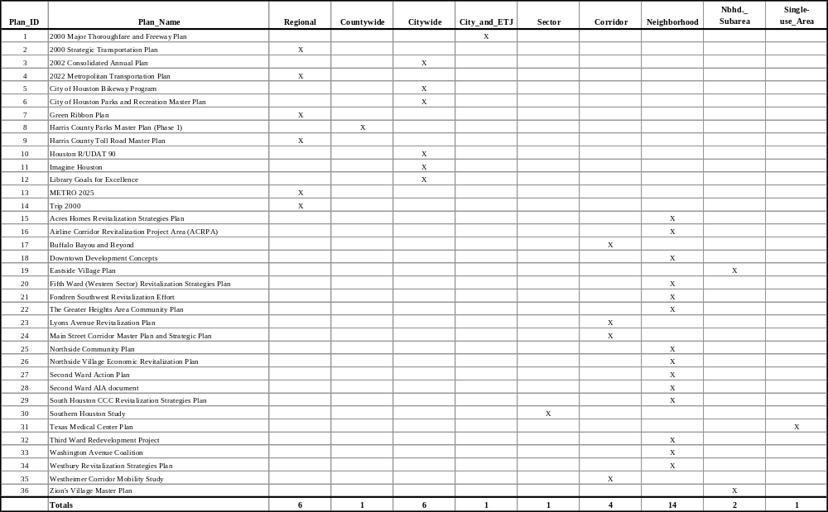
Geographic Scope of Plans

Appendix D-2

Public Agency Sponsorship
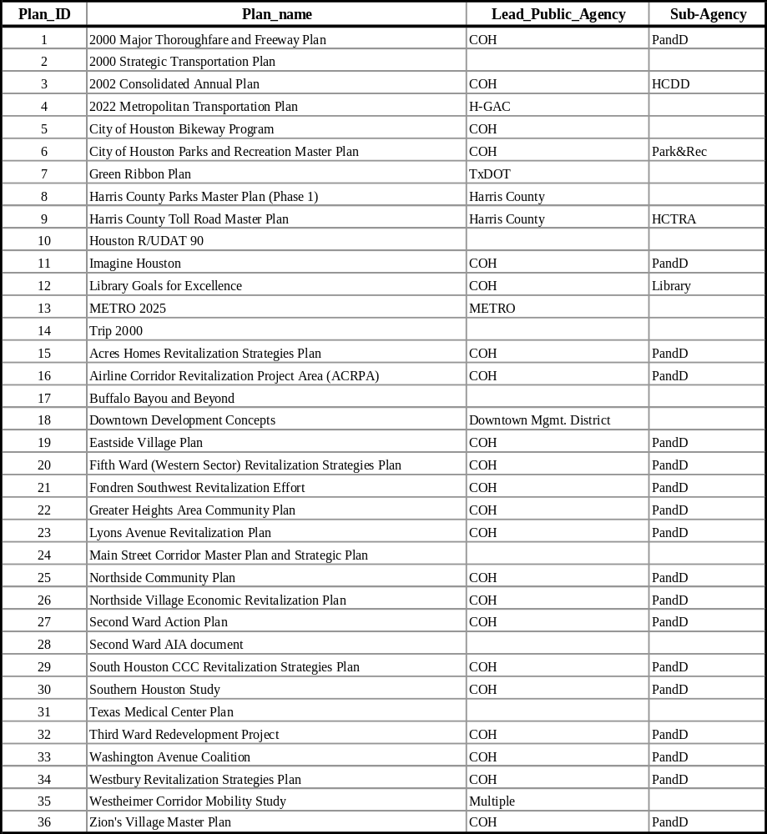

Appendix D-3
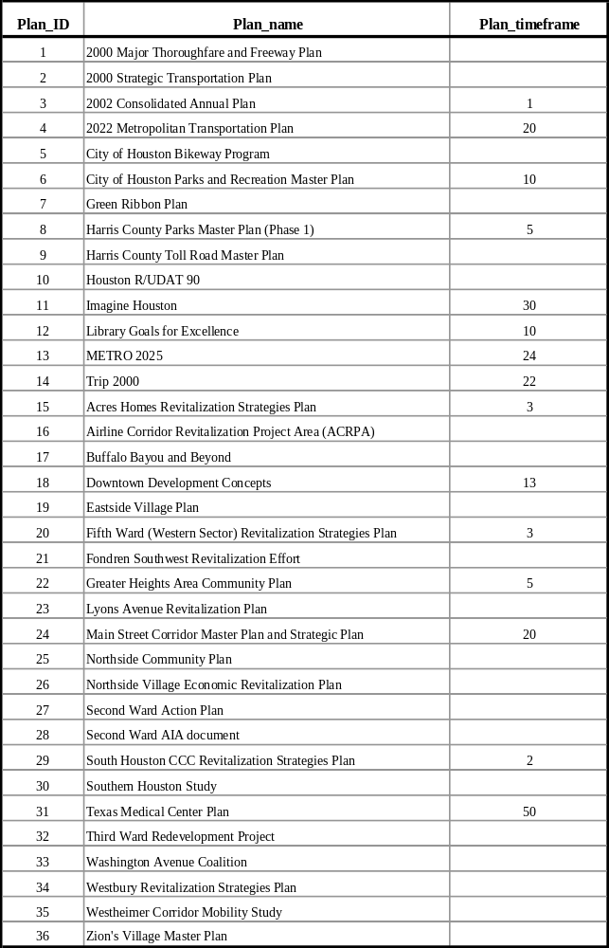
Plan Time Frame
Appendix D-4
Issues Addressed by Each Plan

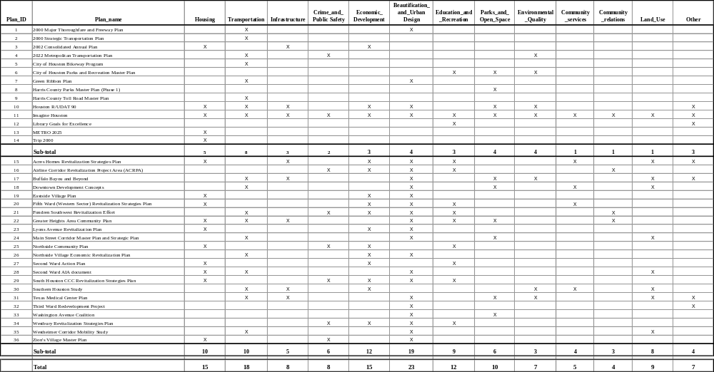
Appendix D-5
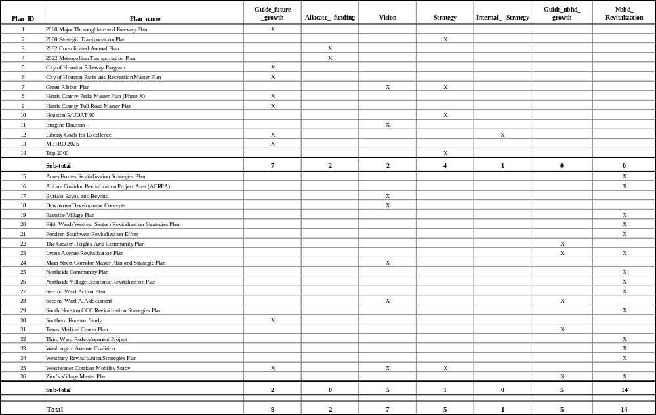
Plan Purposes

Appendix D-6
Plans with Vision Statements and Goals / Objectives

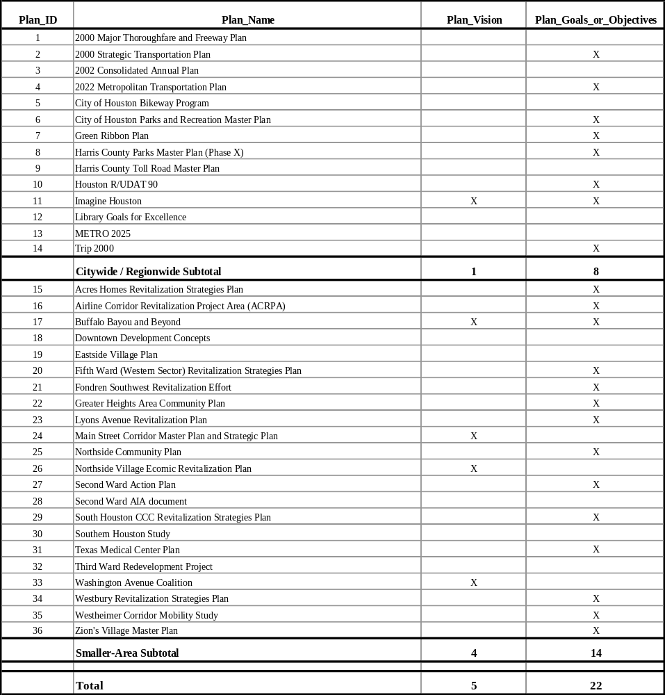
Appendix D-7
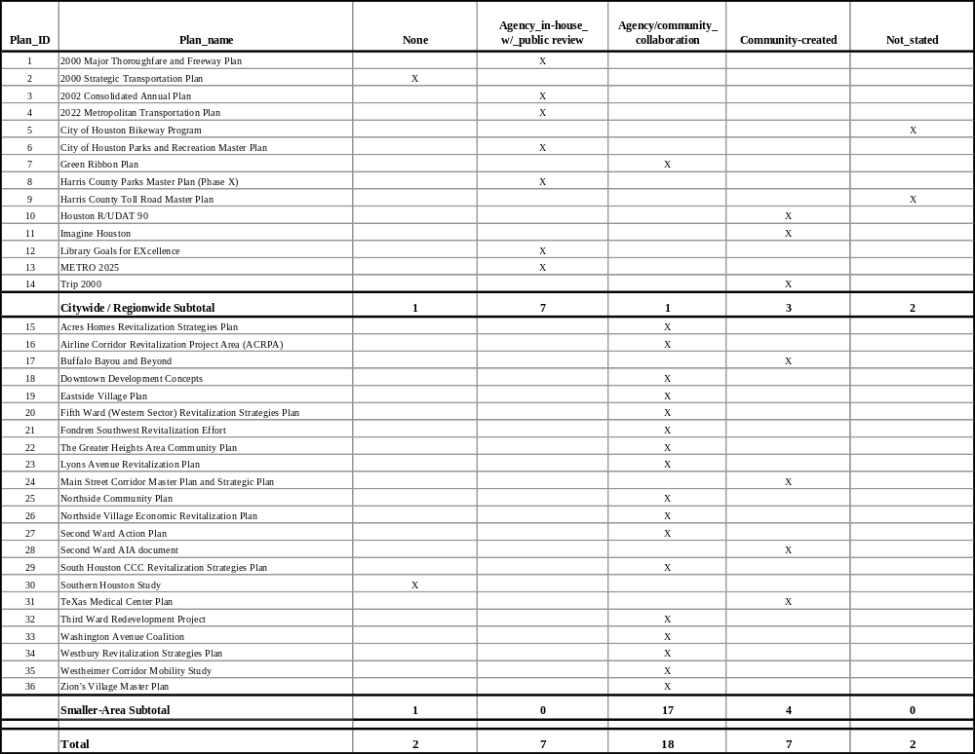
Community Participation
Appendix D-8
Plans with Implementation Strategies
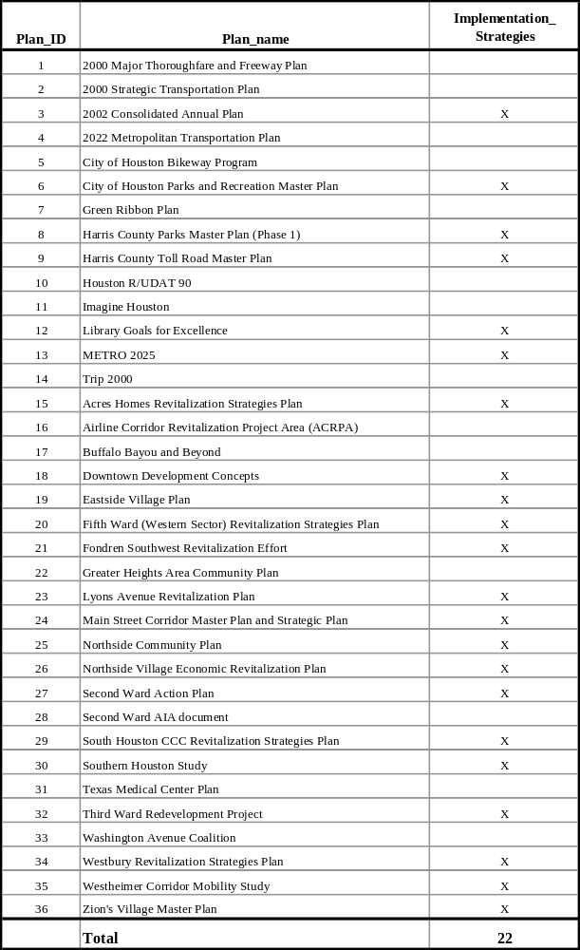
Appendix D-9
Plans with Funding Strategies


