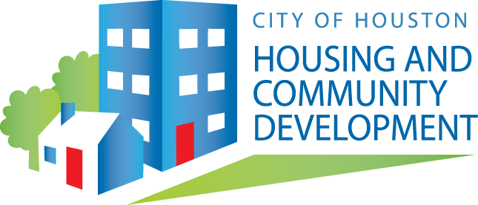
PAYOFF STATEMENT
REQUEST
(FOR HOMEOWNER/S USE ONLY)

Complete and submit this form to hcddloanservicing@houstontx.gov. Please be aware, failure to submit all required documents will delay or prevent the processing of your request. All requests will be processed in the order in which they are received. If you need assistance, please call (832) 394-6200, extension #2.
Homeowner’s Information and Property Information

Date of Request:
Last/First Name:
Property Address:
Phone: Email address:
Occupancy Status

Property is my/our primary residence
Property is not my/our primary residence. What is the last date of occupancy (month/date/year)? _______________________________________
Reason for Request
This request is only to be used for one of the following reason and is not for a sale, home equity or refinance transaction.

Check one or more of the following:

Abandoned property Un-occupied property Death of homeowner(s) Filed bankruptcy
Planning to rent property Renting property Other
Supporting Documentation
Attach the indicated supporting documents:
(The request will not be processed until ALL items are received. HCDD reserves the right to request additional supporting documentation.)

Copy of death certified for any homeowner, if applicable.
Copy of homeowner(s) driver license(s)
Copy of last month’s electric bill. If you do not currently occupy the property as your primary residence, provide the last month’s bill from the time you resided at the property.
Copy of last month’s water bill. If you do not currently occupy the property as your primary residence, provide the last month’s bill from the time you resided at the property.

Feel free to include additional documentation:

Other:
Authorization
An authorization is required by the homeowner/s. Please free to use the authorization below or you may submit your own authorization.

I/We, _______________________________________________________, certify that I/we am/are the homeowner/s of the property. I/we hereby request a Payoff Statement for the transaction that is noted in the reason box above.

Delivery
Payoff Statements are sent via email.

